A VILLAGE IN NEED
OF SOME TLC

Tender loving care has been in short supply here lately, as Seal Rocks seems to have once again dropped off the radar of principal agencies responsible for the upkeep of amenities and infrastructure. The SRPS continues to be pro-active in seeking solutions to ongoing maintenance issues in the village, but to all intents and purposes it seems that no-one is listening.

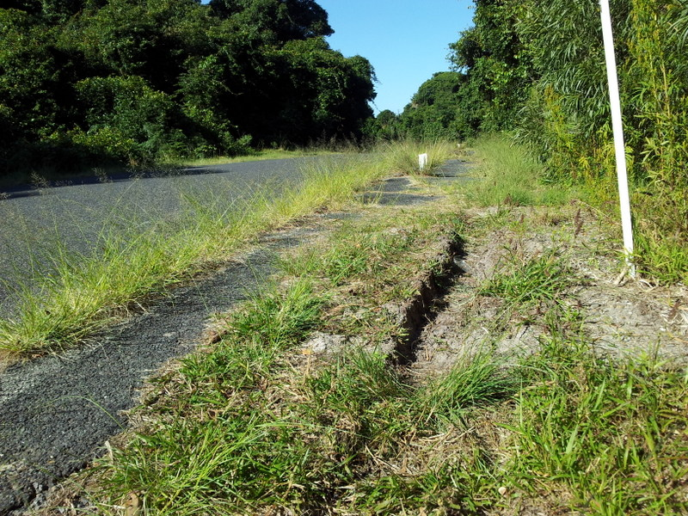
What’s happened to the path?

The roadside footpath from the Holiday Park to the Shop is in such a bad state that it is scarcely recognisable. It is overrun with weeds growing through the bitumen and covered with sand and earth in places. Pedestrian safety is once more being compromised as the growth of roadside vegetation makes the path impassable at some points, forcing people onto the road. Almost all of the white polypropylene reflector posts have been broken off near the base, leaving a string of jagged stumps that are both unsightly and hazardous. Submissions to GLC by the Protection Society led to the installation of this important safety measure for Holiday Park patrons, and it is vital that it should be kept in a state that is fit for its purpose.

Another regular maintenance requirement that is never given attention is the shallow stormwater runoff channel that sits in the middle of the gabion wall on Kinka Road, just down from the Shop. This needs to be periodically unclogged. The result of accumulated silt and debris here is that a greatly increased flow of stormwater washes over the road edge at more vulnerable points further down, where there is evidence of
cracking and subsidence of the shoulder. Also, at the beginning of Kinka Road, the channels that were dug to deflect runoff from the car park area into the vegetation opposite the Shop need to be kept clear so that extra water doesn’t make the problem further down even worse.

At the other end of town, the inland fringe of the Lighthouse car park has also been allowed to silt up, so that, in a downpour, a considerable amount of runoff that should flow over the edge of the bitumen and off into the bush is instead redirected down Kinka Rd. This has recently been exacerbated by the way that the eastern end of the upgraded fire trail falls to this very point, with its long, steep gravel gradient delivering an extra volume of stormwater into the mix. This combined runoff, joining with rainwater streaming off sloping driveways, can produce a flooding torrent by the time it reaches the “Buddha” green overlooking the eastern end of Boat Beach.

It was just such a deluge that caused a landslip at this point in November 2013. As the road had been partially undermined, this required urgent attention, and loads of rock and blue metal were brought in as a temporary fix. At the same time “form one lane” and hazard signs were placed roadside and a few star posts with orange plastic safety netting were fixed along the edge of the washout (see page one header). A few months later geotech test holes were drilled down through the bitumen surface to determine the nature of the road’s foundation. That was eighteen months ago. Since then not only has nothing been proposed as a permanent solution, but no maintenance has even been done on the hazard warning materials in this highly exposed position. They only remain standing because of the running repairs carried out by local residents after extreme weather conditions, but they are fast disintegrating. Whatever is eventually done to fix the road at this point the most important requirement will be to install an effective, site-specific system of stormwater management.
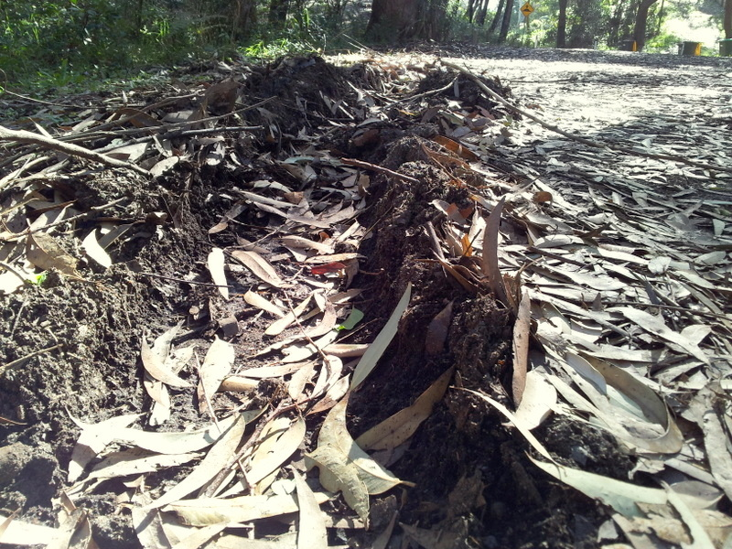
Lighthouse car park sludge – a job for a bobcat ?

Two years ago this month, after a detailed proposal put by SRPS, the Society received correspondence from GLC stating that an application would be made in the 2014/15 budget for an allocation of funds to undertake the necessary preliminary design and survey works for the installation of a permanent public eco-toilet at the eastern end of Boat Beach. Despite two follow-up letters from SRPS since then, reminding Council of this commitment, there has been no further response and apparently no progress. In the meantime NPWS has installed just such an amenity alongside the walk out to the Lighthouse. It can be done!

Just recently it was noticed that, directly opposite the public boat ramp at Boat Beach, the landline phone cable between two power
poles was sagging dangerously low, eventually dropping to below head height at its centre. Telstra was contacted on at least three occasions to inform them, and it is reported that a technician came twice to inspect, but over three weeks went by and nothing was done, despite the cable physically blocking the entrance to two properties. Then on Monday 8th June, about 10.30am, the electricity to the whole of Seal Rocks was cut off without notice. Someone had reported a possible live wire down. It wasn’t until after Essential Energy had come to inspect and the village had endured an unnecessary blackout that Telstra finally restored their phone cable to a safe height.
IN MEMORIAM

The old superstition that deaths come in threes seemed borne out recently with the passing of three long time Bungwahl/Seal Rocks residents within a matter of days, an unnerving concurrence for such a small community, and one that deeply saddened all who knew them.

Elizabeth May Bramble, esteemed teacher and local historian, known to everyone as Betty, passed away on 16th May, aged 82 years, after a long illness. The love and respect in which Betty was held by her family and community was given full voice at the celebration of her life held in the Bulahdelah Central School Hall on Saturday 23rd May. Over 500 people attended the moving ceremony at this place of learning that had been an important part of Betty’s life, and following her wishes, the casket was simply adorned with Bungwahl Fern.

Close friend Jack Brown pays a personal tribute:

Betty Bramble was born and raised Elizabeth May Faulkner in farming country at the foothills of the Border Ranges in northern New South Wales. She received her teacher training at Armidale Teacher’s College.

It was usual for graduating students to be posted to a country town for a rural service period of several years. Betty had a friend at college who was upset at being posted to a place she had never heard of called Bungwahl. Always kind, Betty volunteered to take her place and that is how Betty Faulkner arrived in Bungwahl. She was to stay for the rest of her life and dedicate that life to a passion for teaching. In time she met and married a local fisherman, Colin Bramble, and they established a home on the southern shores of Smiths Lake that they called Shadwell Park.

Betty was gifted with many talents, a remarkable memory, and an interest in all local affairs that saw her prominent in the

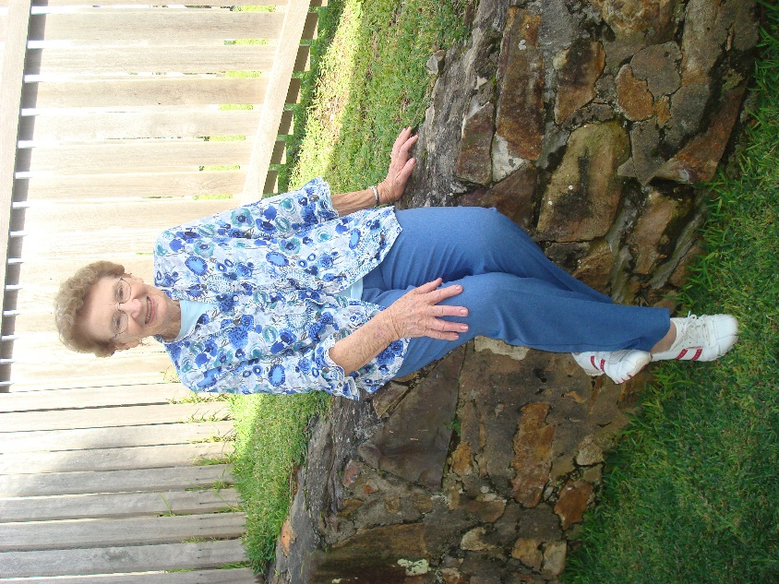
Guest speaker Betty Bramble, photographed at the Sugarloaf Point Lighthouse book launch 20-4-2012.

Bungwahl Progress Association, The Hall Committee, The School Parents’ Association and the Bungwahl Cemetery Committee, to name just a few. An accomplished speaker, she was always in demand as featured speaker at all sorts of gatherings.

Betty and I shared a passion for local history and many of the stories that have appeared on my history page were greatly helped by her advice. Thursday afternoons will never be the same now because on most Betty, sometimes with friends and sometimes just us, would sit on our verandah and relive history or reform the world.

BB you are sadly missed by our group.

Three days after Betty, her brother-in law, well known lakes fisherman Lyle Bramble, who built the Bungwahl fishermen’s co-op on Seal Rocks Road, passed away suddenly, aged 86. Fishing was Lyle’s life and he also built some of the beech wood boats that were used on the lakes. His funeral was held at St. James church overlooking the lake at Bungwahl, on 27th May.
JUNE ALLISON BROWN
1928 – 2015

The same few days saw the death of long time Seal Rocks resident June Brown, who passed away in Taree hospital on 17th May, from complications after a fall at her home in Kinka Road. June was also aged 86 and was born in Cessnock. Her family and friends gathered in the main chapel at the Newcastle Memorial Park in Beresfield, on the afternoon of 21st May, to remember her life and to make their fond farewells.

Sincere condolences, on behalf of the Seal Rocks Protection Society are extended to the families of June, Lyle and Betty. All three will be missed by their community and fondly remembered.

∞ ∞ ∞

It seems appropriate to mention here another death that occurred recently, that of the celebrated wildlife artist William Thomas Cooper, who died at his home in Malanda, south west of Cairns, on 10th May, at the age of 81. Bill Cooper, whose magnificent studies of Australian birds in their native habitat have become justly famous, was born in Newcastle, but lived and worked for many years in the Bungwahl/Seal Rocks area. He shared a property overlooking Myall Lake at Neranie, off to the right near Bridge Hill on Seal Rocks Road. Much of his early work was done there or in the studio/home he built for himself in Sugar Creek Road, Bungwahl, after NPWS resumed the Neranie land. Later he moved to north Queensland to paint the spectacular birdlife of the rainforest there, but kept his links to the Myall Lakes area. David Attenborough, who made a film about Bill and his work in 1993, called Portrait Painter to the Birds, considered him "Australia's greatest living scientific painter of birds” and “possibly the best in the world." Examples of his work, including a number of paintings done around Seal Rocks, can be viewed on his website:
www.williamtcooper.com.au.

HOLIDAY PARK UPGRADE
PROGRESSES

With the winter months now here, upgrade works are continuing apace at the Seal Rocks Holiday Park. While still in Stage One of the implementation schedule, much has been done. The whole central section of the park has already undergone a major transformation with the creation of a new network of internal access roads and the construction of a modern camp kitchen among other things. One striking feature of the design is a long terraced section, running towards the back boundary of the park on the western side, retained by a low wall of huge sandstone blocks. This terrace is where many of the new cabins will be sited. Smart new power and water stations have been installed to service all of the completed short term sites around the south-east perimeter, allowing visitors to camp on this section while other works continue.

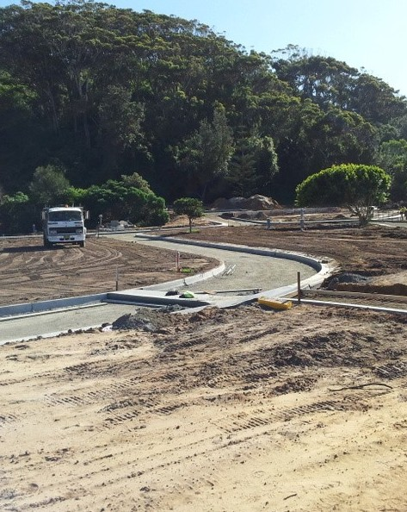 A network of properly drained sealed roads will access every site in the upgraded Holiday Park.

