HOLIDAY PARK UPGRADE
COMMENCES

As January came to a close and the last of the school holiday campers folded tents and disappeared up the Seal Rocks Road, plant and equipment started arriving by the semi-trailer load and the Seal Rocks Holiday Park quickly became a construction zone.

The long running dispute over upgrade plans for the Park was resolved late last year when agreement was reached with the static van owners. Long term vans and annexes were then removed to allow Stage One of the upgrade to proceed and a ballot was held to decide which 16 would return. Preparation of 16 new static van sites is part of the works currently in progress and those successful in the ballot are hoping to be back in by Easter.

According to North Coast Holiday Parks, Stage One is to be in two parts – pre-Easter and post-Easter, with a projected break during the holidays, and concentrated on the southern and south-eastern areas of the park.

The pre-Easter phase now underway will see extensive stormwater drainage installed, along with utility services to the new sites and the realignment of some access roads, although it is not expected these will be sealed until post-Easter. Installation of a new sewerage treatment plant, in a different location from the present one, away from the centre of the Park, is a priority and is also part of Stage One.

After Easter, works in this initial stage will be finished off and there will then be a gap until the commencement of Stage Two, which has not been funded in the present financial year.

In Stage Two, new stormwater drainage and utility service upgrades will be extended to other areas of the Park, and more road alterations will take place, including a realignment of the Park’s entrance. In this phase a new manager’s residence and office will be erected. The Park will continue to operate in a limited capacity as the progressive changes take place.
DEALING WITH VANDALISM

While most people accept that signage is a necessary means of conveying information to the public and that gates and other barriers serve a useful purpose in protecting the environment from vehicular abuse, there are always those who see such installations as an unwelcome intrusion of authority and wilfully set about damaging or destroying them.

Vandalism is a common occurrence in National Parks, where vast areas and numerous unattended sites are the norm, and is a continuing problem for the rangers who have to deal with it.

Increasingly, hidden security cameras are being used to monitor ‘vandalism hotspots’ and recently in the Myall Lakes National Park such surveillance resulted in the successful prosecution of a Raymond Terrace man who was caught on camera wrecking the gate to the old mining trail off the Seal Rocks Road. He was ordered to pay $4740 in compensation and a second man is still being sought by police.

On Lighthouse Beach, the signage designed to assist control of 4WD activity and protect the dune system has often been a favourite target of vandals, and NWPS staff are considering the most effective way of identifying culprits there and solving what is proving to be an expensive and time consuming problem.

DISTRICT ROAD WORKS

A couple of GLC road projects currently in progress in the area may cause short delays as you approach Seal Rocks: an upgrade of almost a kilometre of The Lakes Way just south of the Bungwahl cemetery should be completed by late March. Improvements are being made to the foundation of the road and to the drainage from the shoulders to prevent the constant degradation of the bitumen surface, which happens especially during and after extended wet periods.
A similar project, but on a smaller scale, is underway on the Seal Rocks Road in the area of the Bungwahl School. The road shoulders are being reconstructed, the road resurfaced and drainage adjusted to obviate the serious ruptures that occur to the pavement here after rain. Although the budget for these works is more modest, it is planned to widen the road to allow for a sealed informal bus stop bay, positioned adjacent to the school.

Then, in the next financial year’s budget, GLC intends to make a further allocation, to upgrade the section of The Lakes Way starting at the Seal Rocks Road turnoff, and going south through Bungwahl past the site of the old timber mill. Improvements to road alignment will be made here, although private property boundaries will place limits on what is viable.

GARDEN ESCAPEES

No they’re not criminals hiding in the shed, they’re the 65 percent of bushland weeds that were originally home garden plants and whose seeds have been dispersed by wind, wildlife and garden waste dumping.

There has been a major effort around Seal Rocks in recent years to protect the native biodiversity, and many SRPS members have been a vital part of that effort, but ongoing vigilance is the key to success.

This autumn, GLC and NPWS are launching ‘Backyard Bushcare’, an information program designed to highlight the problem throughout the Great Lakes region and get the wider community actively involved in weed control.

Most people in Seal Rocks are aware of Bitou and Lantana, but there are many other plant species that pose a threat and prominent among these are Cassia and Asparagus Fern, of which there are a number of species. These need to be removed from your property and placed in the Council green waste bin.
THE ROCKS

They were created millions of years ago at a time of tumultuous volcanic and tectonic activity. In the aeons since then, due to the comparatively stable geological conditions in this part of the world, the forces of nature have been able to go to work, re-shaping them through erosion. The rocks of Seal Rocks provide a window into the structure of planet Earth, and their diversity turns a walk along the beaches and around the accessible headlands into a rare visual treat. From the huge concretions of Melon Beach, through the honeycombed sandstone, to the patterned shale, ironstone and volcanic faces of the cliffs, the sculptural forms, vivid colours and distinctive textures of these rocks give unadulterated pleasure to the eye.

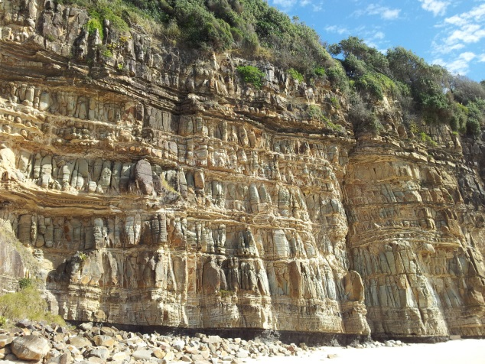


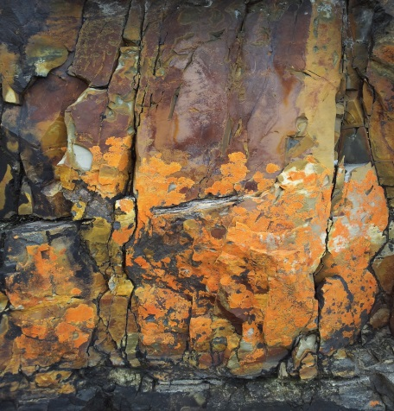

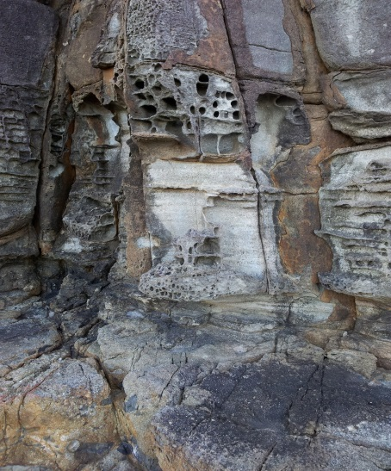

* * *

HAPPY BIRTHDAY JACK

Protection Society Co-Founder, erstwhile Treasurer, current Vice President, historical correspondent, general inspiration and Seal Rocks Legend Jack Brown turned 90 on 27th February. Heartiest Congratulations Jack on behalf of the entire membership,
and may there be many more years and many more tales to tell.

* * *

The History Page

BUNGWAHL COMMUNITY HALL

It’s a historic building that has well served Bungwahl and Seal Rocks locals and others throughout the Myall Lakes region for over a hundred years, but what might not be so well known is that the current community hall was not the first in Bungwahl.

Towards the end of the 19thC, Alexander Croll, the owner of the Bungwahl timber mill, who held all the surrounding land, built the first hall directly across the road from the site of the present one, with one end of the building facing the road. This hall could hold maybe a hundred people, and was enjoyed by all as a social centre until it was outgrown by the rapidly expanding population. Because of his connection to a place in Scotland, Mr. Croll called it ‘Huntley Hall’, but it was always known in the district as ‘The Old Opry’. Once past its use-by date, the back half of the hall was demolished, and the front half converted into a cottage that the postmaster lived in for many years. People might remember this small weatherboard house sitting close to the road, until it was demolished not that long ago. Co-incidentally, Mr Croll also built a tennis court further back on the block, which is the site of the present fire station.

For the second hall, initially known as the Bungwahl School of Arts, Mr Croll donated the land and the milling of the timber, and money was raised for the works in the form of debentures being offered to local residents, although no-one was permitted to invest more than £10. The principal builder was a highly respected master craftsman, Tom Palmer, assisted by local volunteers. So successful was the hall when completed in 1914 that investors were paid back with interest after just two years.

The hall has been somewhat altered over time, but in the early days you entered from the southern end of the building, up some steps and into a central hallway. Off this was a small supper room with trestle tables. On dance nights there would be at least three sittings of supper. A small ‘box-office’ opening in the wall was where you paid your entry fee. On the other side of the hallway was a billiards and reading room. A weekly billiards night was very popular, and helped a great deal in paying off the hall.

A state government program to improve literacy saw a large crate of books and papers sent north by the State Library every month. The papers could be a month old, and the overseas papers six months old, but people were hungry to read the ‘news’. The reading room also housed the lending library, and after a month Mr. Croll would repack the crate and send it back. The larger room behind the main hall was a dressing room. Many people rode in to the dances on horseback, with their ‘good’ clothes in a saddlebag, and when they arrived used this room to get changed in.

During and beyond the first half of last century Friday nights at the Bungwahl Hall could see up to 200 people arrive for games of darts, indoor bowling and chook raffles among other entertainments, with Syd Bale running the show. There were regular dance nights, when a small orchestra would be hired, and night lights were rented from Krambach. Incredibly, electricity wasn’t connected until the mid-1970s. In the early days Colin Bramble’s grandmother played the piano and the accordion, and Pant Johnson from Mayer’s Flat played the violin. Harry Atkinson was also a very good pianist and entertained during the orchestra breaks, and later on Owen Gee played the drums. These nights were legend. Although there was relatively little beer in those days, spirits were always in plentiful supply. It is nice to know that you can still experience something like these times if you attend the bush dances that are held from time to time in the Bungwahl Community Hall today.

* * *

(Many thanks to Betty Bramble for much of this information)

