SEAL ROCKS LAUNCH FOR CHARITY RUN

The grounds of the Seal Rocks Shop provided the venue for an early morning barbecue breakfast on Wednesday, November 5th. Hosted by the SRPS Treasurer, Nadine Wilson and her husband Chris, who organised a production line of delicious bacon and egg sandwiches, this event attracted a sizeable crowd of visitors and local residents to witness the start of a taxing 150 kilometre five-day charity run from Seal Rocks, south to Whitebridge.

The aim of Charlie’s Run 4 Kids was to raise funds that would assist a young girl from the Newcastle area, Charlotte Carr, (Charlie), who requires intensive ongoing treatment for neuroblastoma, a cancer of the sympathetic nervous system that occurs almost exclusively in infants and young children.

An intrepid group of sixteen volunteer runners associated with Charlie’s family had

been in training for months, and were being sponsored in this endeavour by a large number of organisations and individuals. The morning at Seal Rocks was fine and sunny, tempered by a bracing sea breeze, and just before 7.30am the signal was given for the run to begin. Conspicuous in their eye-catching hot pink singlets, the assembled runners began to jog out of town at the start of their tough challenge, closely followed by their escort safety vehicle, warning of ‘Runners on Road’.

After five demanding but enjoyable days the event finished on Sunday, November 9th, at the Burwood Colliery Bowling Club at Whitebridge, with the inspirational long distance athletes rewarded with the great news that just under $98,000 had been raised so far, including the $500 contributed by the Seal Rocks barbecue. Congratulations to the runners for their determined efforts, and to all involved in bringing about such a successful outcome, and most of all, best wishes to Charlie Carr during her future treatment.
THE PERILS OF PARADISE

There have been a number of reminders this year that the natural beauty of the Seal Rocks area also conceals many dangers. In May, four fishermen were swept into the sea from a rock platform and, though three were rescued, one perished and was never found. In July, a young woman was badly injured when she fell 20 metres down a cliff at the far end of Number One and had to be winched from the rocks by the Westpac Rescue Helicopter. In September, treacherous seas ripped yet another yacht from its anchor and washed it ashore on Boat Beach, from where it had to be craned onto a truck and taken off for repairs.

Most recently, a 28 year old Tuncurry resident, Michelle Mansfield, suffered a severe snakebite while walking after dark along a bush track at Treachery and is very lucky to have survived. Apparently Michelle was returning with friends to their site in the lower camp after having been out on the Headland at dusk, when the snake struck her above the heel. No one in the group was carrying a torch but the light from a mobile phone picked up the reptile slithering away.

If the victim’s limb had been immobilized immediately there would have been a slower reaction, but she walked the distance up to the Treachery Camp Office, allowing the venom to move more rapidly through the system, and shortly after arriving at the office showed signs of collapse.

Fortunately, Treachery Camp Managers Kevin and Sally Marvell, well trained to deal with such emergencies, knew exactly what to do, and after immobilizing the limb with a splint and bandages from ankle to thigh, kept Michelle from slipping into a coma while waiting for the ambulance to arrive.

Later, in Manning Base Hospital, the patient had a severe allergic reaction to the anti-venom injected, which didn’t help matters, and had difficulty breathing for 40 minutes, until stabilized with further medication.
There is an element of mystery as to the
identity of the snake species that did the damage. The swab taken at the hospital showed it to be a Tiger Snake and that was the anti-venom given. But no one with local knowledge has ever seen a Tiger Snake in this area. Kevin Marvell, whose first thought was that he might be dealing with a Death Adder bite, is now convinced that it had to be a Stephen’s Banded Snake, a venomous nocturnal species, not unknown in this area, with a reputation for being ill-tempered, and part of the broad headed group. According to the literature, the specific anti-venom indicated is the same as for the Tiger Snake, which possibly explains the pathology.

A very relieved Michelle has subsequently recovered and returned to work.

( Jack Brown gives some timely advice on snakes on page 4)

* * *

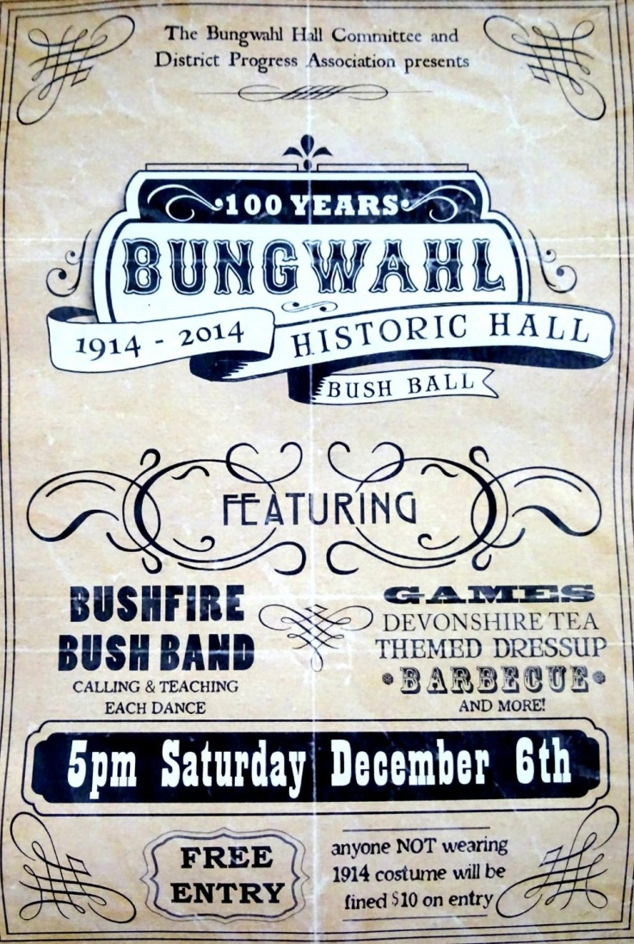

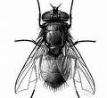The Buzz

BRAVERY AWARD

Congratulations to Pacific Palms SLSC’s Lennon Fisher for receiving Surf Life Saving Australia’s Meritorious Award recently at a ceremony in Sydney. The prestigious national honour was given in recognition of his outstanding bravery in rescuing, under extreme conditions, one of the four fishermen involved in the rock fishing tragedy at Seal Rocks last May. If anyone deserves the title “Lifesaver” it is Lennon. He and his trusty jet ski have been involved in numerous rescue dramas over the last couple of years and at least seven people owe their lives to his courage and skill. Well done Lennon! The whole Community is proud of you!

BUNGWAHL HISTORIC HALL CENTENARY

On Saturday, 6th December, commencing at 5.00pm, a bush ball is to be held in Bungwahl’s Historic Community Hall. Featuring an array of music, dance, games and food, this will be a celebration of 100 years of continuous service to the local community by this fine timber structure, built by local master craftsman, Tom Palmer, and opened in December, 1914. Entry will be free for all who dress in a costume reminiscent of the era, otherwise a $10 ‘forfeit’ will be required. The genesis of this ‘new’ community hall, the second to be built in Bungwahl, is very interesting in itself. The original Bungwahl Hall, known as “The Old Opree”, was directly across the road, and was later transformed into a house and survived until quite recently, when it was demolished. A future edition of the newsletter will feature an expanded history of the second hall, which also catered to the Seal Rocks community. In the meantime, on 6th December the whole family can come and enjoy a genuine country bush ball, and join in the special Centenary festivities.
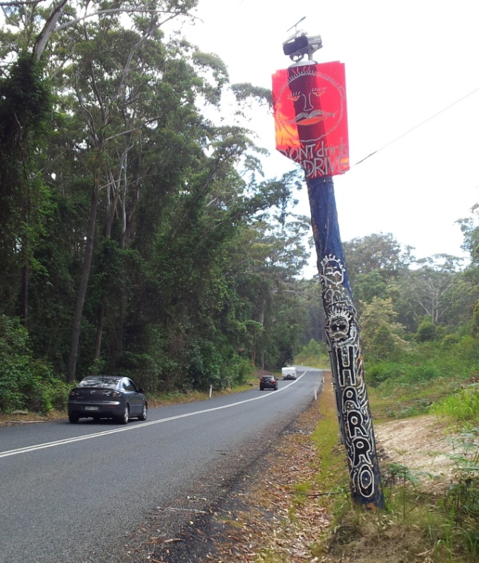

FIRST SEALED ROAD SUMMER

With Harro’s newly updated and CCTV camera-equipped “Don’t Drink and Drive” pole now standing sentinel alongside a fully sealed approach to the village, we are all anxiously awaiting the first summer holiday period without the disincentive of a 2km strip of gravel and potholes to annoy and deter motorists and bike riders alike. If the experiences of last Easter and the recent October long weekend are any guide, the narrow village roads will once more be swamped. Police assistance may again be needed to keep traffic moving in both directions, especially along the road adjacent to Number One beach, despite the new line of bollards and the No Standing signs.

* * *


Nov/Dec brings the Blueberry Ash

Jack’s Page

ABOUT SNAKES

It is that time of year when snakes become active and move about, and we might find ourselves in their territory. Awareness of the snakes found along the east coast is useful in both avoiding them and knowing what to do if bitten by one. Here is a short list of snakes found in the area and some observations on them:

- The Pythons: Two varieties - the Carpet Snake and the Diamond Python – can grow to 2 metres – feed on mice, rats, frogs and carrion – both non-venomous, but can bite if annoyed long enough – slow moving and non-aggressive - often seen crossing a road or path.

- Red Bellied Black Snake: Quite common and active in warmer months - grows to about 1.5 metres – feeds on frogs, mice etc. – bite is venomous but rarely fatal – can sense vibrations and will usually move away quickly – often seen basking in the sun – if there are lots of Black Snakes about, the Brown Snake is rarely seen.

- Eastern Brown Snake: Occasionally seen in the area but Black Snakes are much more common - bite is venomous and can make the victim very ill –will usually move away quickly.

- Common Death Adder: Not often seen, as it is nocturnal and also good at disguise – slow moving and usually hides in dense leaf litter - doesn’t move around much – will stay motionless for hours with head facing its tail end, which it moves to simulate a worm or small lizard in order to catch small birds etc. - bite is venomous and very serious.

- Green Tree Snake: A beautiful non- venomous snake that climbs trees and bushes – feeds mainly on small frogs – will move away quickly if disturbed.

- Stephen’s Banded Snake: Black dorsal area with narrow cream crossbands - arboreal and nocturnal – pugnacious by temperament - 0.5 to 1 metre in length – venomous.

What to do if confronted by a snake:

Never try to hit it or kill it – this will only make the snake aggressive. If the snake is quite close, do not move, but stand motionless until you assess the situation – snakes do not bite stationary objects. If the snake is facing you it can see you, so avoid sudden movement and back off slowly. If you are behind the snake it will not see you and it is safe to retreat. Remember that snakes can only move at about 6 kmph, so a human can outpace a snake.

What to do if bitten by a snake:

Rapid attention is essential, but it is important that the patient avoids movement and vigorous action such as running. Have someone send for an ambulance.

Immobilize the affected limb and wrap it completely from the extremity up as far as possible with broad elastic bandage. Then place the limb in a sling if it is an arm, or apply an improvised splint if it is a leg.

This is done because the venom works by travelling to the lymph glands and bandaging slows this process down, often by hours. Do not wash or swab the bite area, as the medicos will need to swab it at the hospital to identify the type of snakebite and thus use the correct anti-venom. It is a good idea to carry an elastic bandage and a sling in the car first aid kit.
Jack Brown

