MOVEMENT AT THE STATION

With the end of the holiday season, a number of major infrastructure projects have finally got underway at Seal Rocks. All of these have been on the bureaucratic roundabout for years, working their way through studies, consultations, reports, plans, subsidy applications - you name it. Most have been subject to numerous delays, usually caused by budgetary constraints, and the irony is that they are all now happening at the same time, in a sort of collective rush to be well advanced, if not finished, before the end of the current financial year.

- SEAL ROCKS ROAD

No one could miss the plethora of signs (dazzling by night, rivalling Sydney’s Vivid festival), leading up to the temporary traffic lights (usually red) which presently greet us either coming or going along the Seal Rocks Road. The ‘cut and fill’ earthworks for the seal of the final 2.2 kms of the road are well under way, and whether we are for it or against it, come August, there will be

bitumen all the way from the Lakes Way to
the Lighthouse. Some can hardly wait, while others believe it spells ruin for the village. Most are probably ambivalent, wanting an end to those bone-crushing pot-holes, but apprehensive at what that might mean. Change will inevitably occur, as it has progressively from long before they put the first stretch of tar up Bridge Hill decades ago. Those who witnessed the gridlock at Number One on Easter Saturday must wonder if that last couple of kilometres of gravel deterred a single potential visitor anyway. Will it get worse? Probably. Can we deal with it? We’ll have to.

- FIRE TRAIL UPGRADE

Improvements to the bushfire defences behind the village, dubbed the Seal Rocks Perimeter Fire Trail Project, are nearing completion, in a collaboration between Crown Lands, NPWS and FLALC. The project is supervised by the Soil Conservation Service and fully endorsed by the Great Lakes Bush Fire Management Committee.
The previous trail was deemed inadequate for safe and effective use by fire fighting appliances and the new, extended, all-weather trail will “enhance property protection, emergency response capabilities and augment options for fire management”.

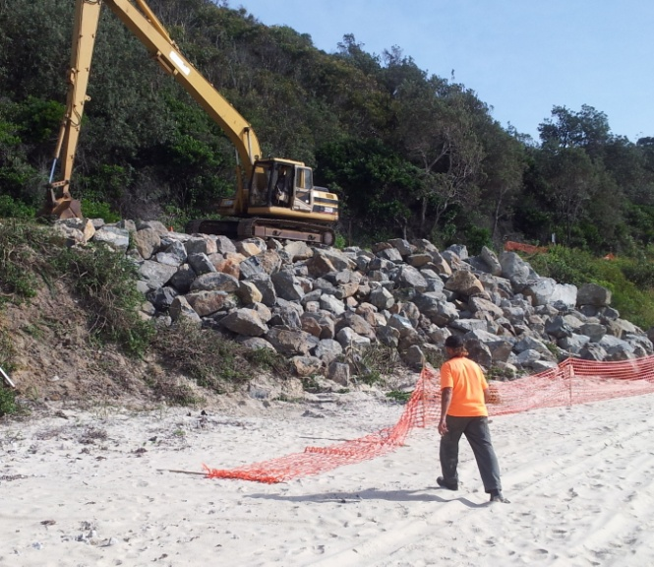
Using the ‘cut and fill’ method, steep gradients have been substantially reduced, and at the eastern end the trail now extends as far as the Lighthouse car park. Vast amounts of gravel have been moved from the compound set up in Thomas Road and dumped along the trail carved through the dunes, forming a viable all-weather base. To all intents and purposes a new road has been created behind the village. Although this will be gated at appropriate points and access will be restricted to fire and management vehicles, it will potentially provide the often suggested emergency route, should some unforseen disaster ever close Kinka Road.

- HAZARD REDUCTION BURN

The much-postponed hazard reduction burn of that part of the National Park behind Seal Rocks finally got the go-ahead on Tuesday, 29th May. Volunteers, fire crews and personnel from various agencies swung into action when all the weather variables seemed to line up in favour of proceeding with this vital safety element, one of several measures designed to protect the village from a high-intensity summer bushfire.

The strategy was to start the fire from the west, this side of Treachery, and keep it to the understorey as much as possible as it burned towards Kinka and Thomas Roads. In a timely piece of good fortune, a stiff nor-east breeze arose as the fire approached the village, making the fire front much easier to control. The successful outcome was described by Rachel Kempers of NPWS as a near textbook result of a ‘mosaic’ burn, with small sections of bush unscathed, the fire getting up into the tree canopy in relatively few places, and the combustible material on the forest floor effectively removed. Well done, and thanks to everyone involved.
- EROSION REPAIR NUMBER ONE BEACH

Subsidised by funding from the Australian Government’s Natural Disaster Relief and Recovery Arrangements, Great Lakes Council is currently constructing a very large rock revetment wall to address the erosion at Number One Beach. In the recent past, storm surges combined with high tides have been gouging away the base of the bank that supports Seal Rocks Road, threatening to undermine the only access road into the village.

Stage one of the sea wall at Number One

A preliminary series of geo-technical tests were needed to determine the exact nature of the material that lies beneath the road surface, and the location of a solid foundation point from which to build a stable defence against wave attack. There is quite a science to getting this right, as it is not unknown for failure to occur if the construction isn’t exactly suited to the location and the way the reinforcement is bedded, no matter how large the rocks are that are being used.

Although the initial plan at road level was for a tensioned cable traffic barrier between the edge of the road and the top of the wall, Council’s Works Engineer, Will Barr, has now confirmed that this barrier is instead most likely to comprise a line of treated pine bollards.
Rescue Team embarking at Boat Beach
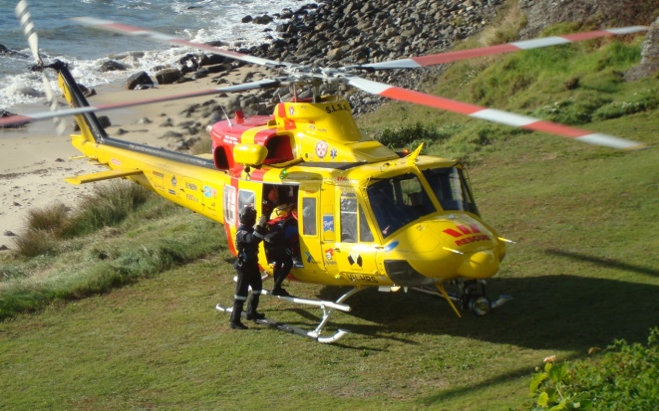
FISHING TRAGEDY

An extensive air and sea search failed to find missing Goulburn fisherman Peter Oberg, washed off a rock ledge at Seal Rocks with two of his mates around noon, Wednesday 7th May. Four friends from a party of six staying at a house in Kinka Rd. had abseiled down a cliff between the Gap and the Lighthouse. Though the Bay was calm, the waters on the other side of Statis Rock were treacherous, and a sudden surge caught the fishermen unawares. None were wearing lifejackets. Of the three swept in, one managed to get back onto a rock platform and was later winched to safety by the Westpac Rescue Helicopter. A second was found cut, bruised and freezing, clinging to rocks, and was rescued by Pacific Palms lifeguard Lennon Fisher, using a jetski. The third man, Mr. Oberg, was last seen floating face down in the water, but disappeared shortly after and is presumed drowned.

The Buzz

TIGER MOTH AIR RACE BACK ON

The vintage air race that was scheduled for last Anzac Day weekend had to be cancelled due to a late notification of compliance requirements by the Civil Aviation Safety Authority.
The latest news from the race organiser is that this event will now take place on the holiday weekend of 4th and 5th October. Let’s hope that all goes smoothly this time!

BUSH REGENERATION
CONTINUES

Although the proposed retaining works to address the landslip on Kinka Rd., above the reserve at the eastern end of Boat Beach, are expected to impact significantly on the Weed Warriors regen project there, weeding has nevertheless recommenced, in order to consolidate past gains.

Meanwhile, much other native regeneration work has been happening in and around the village. Parcels of land controlled by GLC, Lands Dept. and National Parks have been successfully treated with herbicide, and pink protector sleeves can be seen along part of the Number One beach foreshore, where Miles Dixon and volunteers have been busy planting endemic tube stock. NPWS have conducted their 2014 aerial coastal bitou spraying program, and a joint exercise with GLC to remove noxious weeds from private properties in the village has begun.

ON THE MEND

Patrons of the Seal Rocks Shop will all wish Ray Horgan a speedy recovery as he convalesces after recent bypass surgery.
It shouldn’t be too long before he is back behind the counter and in full fettle. Meanwhile, take it easy Ray while you have the chance!

* * *

© Stephen Brown

Jack’s History Page
BULLOCK DRIVERS
In the days before modern bulldozers and other equipment became available to bring the logs out of the forest, it was the job of the bullock driver and his team.
The area around Bungwahl and the forests inland towards Bulahdelah were a significant source of timber and bullock teams were part of this industry. Bullock teams were not only used for logging, but were the main means for transporting all sorts of loads.
Back when the Lighthouse at Sugarloaf Point was being built it was necessary to transport not only the components for the light itself, but also all the building materials. Most of these materials were landed at Boat Beach and moved to the site by bullock teams operated by John Bramble. The Lighthouse construction site could only be reached by a steep incline with a very restricted turnaround area. It was so tight that the bullock team had to be unyoked and turned around in small numbers before being re-coupled for the return journey.
Palmer’s bullock team and drivers taking a break on the road near Bungwahl. They are hauling a huge log to the local sawmill. In the local forests a well-known Bullockie was one George Godwin, who had several teams operating in the area. One of his drivers was George Mitchell. Another team was run by the Palmers, who hauled logs to the Croll mill at Bungwahl. Yet another well-known team was that of the Corrigans, operated by John Corrigan and his nephew Bill O’Brien, who was only sixteen years old. They also carted logs for Croll’s mill.
A great deal of timber was taken from the forests between Bungwahl and the Wallingat River. The tracks from the river roughly followed what is now Sugar Creek Road, and evidence of these tracks is still to be seen in the bush alongside the present road.
To go out as far as the river was a slow march and required an overnight stopping place by the river and a resting paddock there for the bullocks. Some logs were loaded onto water transport at that point to be taken as far as Forster.
The most important part of the bullock team was the two leading bullocks. If these two were docile and well trained, then the job of the driver was that much easier. The number of beasts in the team varied from six up to as many as twelve.
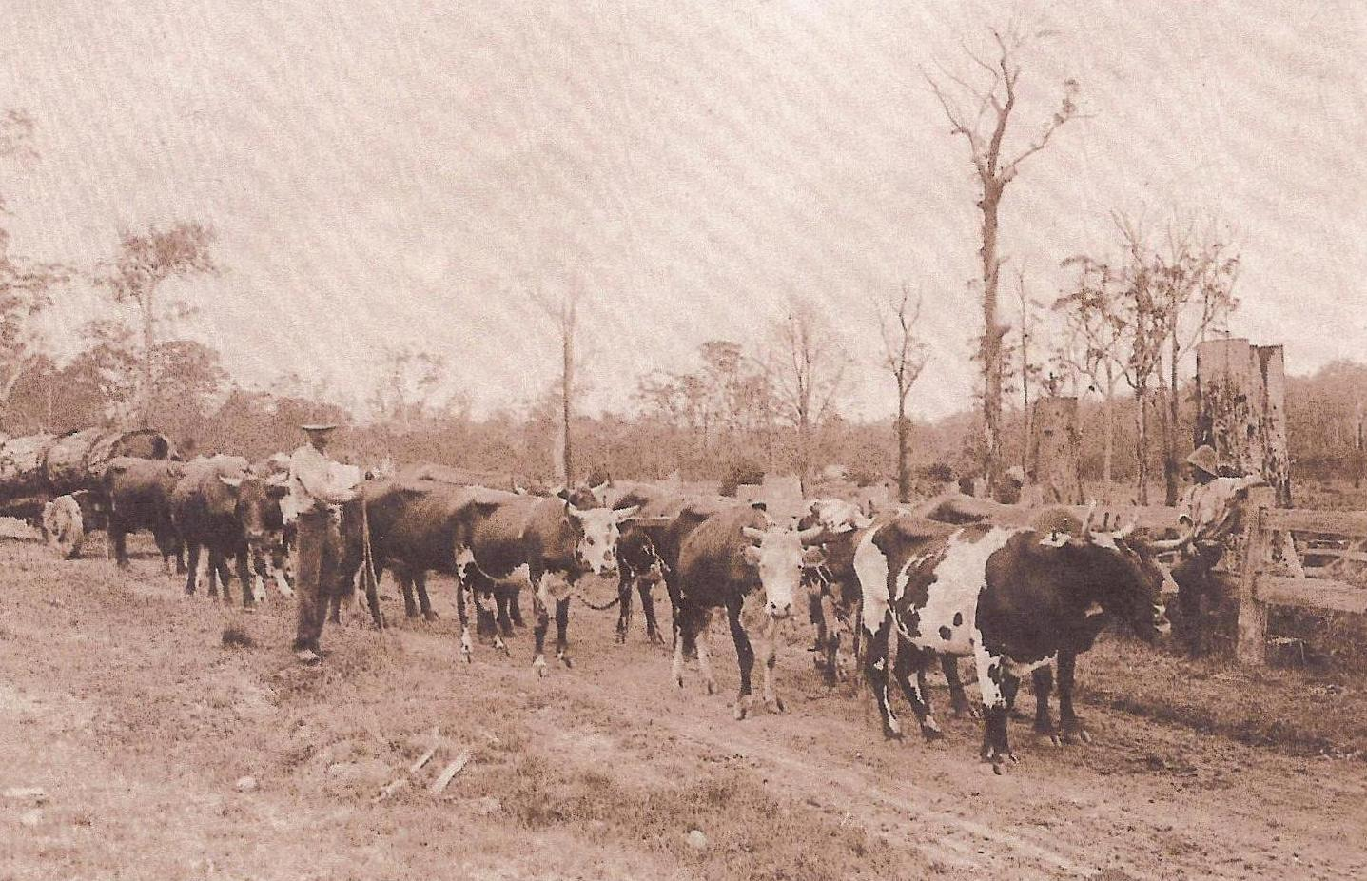
Bullockies were a very hard-working group, and after work, a very hard-drinking mob at the local pub. There were a lot more teams in the area than the ones I have named, but I hope I have given some idea of the significance of the Bullockies in ‘the good old days’.
(My thanks go to Betty Bramble and Marie Davies for their valued input.)
Jack Brown

