THE GREAT TIGER MOTH AIR RACE

Seal Rocks is in for an uncommon treat on Saturday 26th April, with Sugarloaf Point Lighthouse playing a major role in an air race involving about 45 Tiger Moth aircraft from all over the country and overseas. The event is being organized by race director, Richard Brougham, and is being held over Anzac weekend in honour of Australia’s Armed Forces.

The 2014 race, The James Strong Memorial, will begin on Anzac Day, when veteran pilot Bill Purdy, who is 91, leads the formation for a memorial flyover of the Sydney Harbour Bridge, before the field heads off towards the mid-north coast. Mr Purdy is one of the few surviving Lancaster Bomber pilots of WW2, with many a bomber captain having been taught his initial aviation skills on a Tiger Moth.

Then on day two, Saturday 26th, the race continues in earnest, when all the planes depart from Taree Airport starting from 1.00pm, head out over Old Bar, and then track down the coast to Seal Rocks. It is here that a vital part of the race will take place. As the field passes over the Lighthouse and turns inland towards their next destination, Stroud, each pilot will have to fly low to identify a secret letter of the alphabet

that will be staked out on the ground of the lookout area. This is to ensure that everyone flies the correct route. Volunteer observers on the ground will record the registration number of each plane as it passes overhead, and the time it reaches the Lighthouse. This data will be relayed back to the race organizers.

The Great Tiger Moth Air Race was inaugurated in 1977, with just over a dozen races run in different locations since then, the last being held 11 years ago. This year’s event, hosted by the Royal Newcastle Aero Club, is being staged to support two very worthwhile charities. The Hunter Valley based ‘LIFT’ Youth Development scheme is aimed at helping young people deemed to be “at risk” by teaching them decision-making life skills and risk-management strategies through aviation, while ‘Soldier On’ is a multi-faceted fund-raising program designed to assist in the rehabilitation of Australian soldiers experiencing physical or mental complications after returning from overseas tours of duty.

This vintage air race promises to be a rare spectacle, and falling on the last day of the Easter school holidays, should be something that the kids will remember about their stay at Seal Rocks for years to come.

ROADWORKS

Great Lakes Council is well into the planning process for some significant roadwork projects in our area in the near to medium future. The Engineering and Works departments are currently awaiting a report from Regional Geotechnical Solutions, the company that conducted drilling of subsoil samples along the affected areas of Kinka Road and Seal Rocks Road in the first week of February. These are the same specialist consultants that designed the gabion wall cages for the two retaining wall projects that remedied the landslips just below the Shop.

The analysis of these recent samples will determine the extent and configuration of the new retaining works needed to rectify the roadside erosion problems at Number One Beach and on the hill leading up towards the Lighthouse car park. The plan for the Number One site is apparently the more advanced, and current intentions are that this will be tackled first, before the end of the financial year.

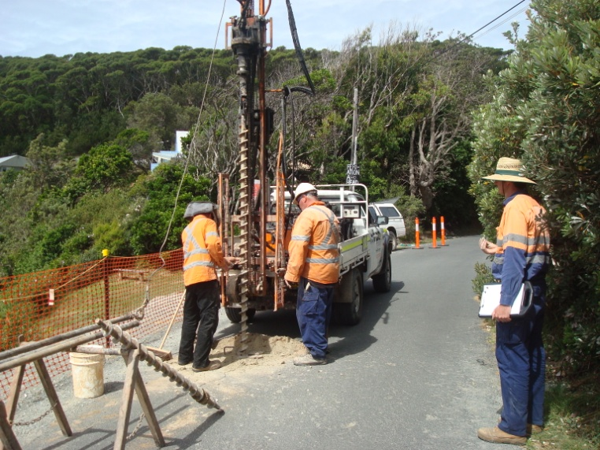
Drilling on Kinka Road

Also within that time frame, Great Lakes Council proposes to continue with the works required to seal the remaining gravel section of the Seal Rocks Road. It is presently unclear, and will depend upon financial considerations, whether the entire two kilometre stretch will be completed in one stage, or in two stages, funded by separate budget allocations.

SAD EVENTS

News has come to hand of the recent passing of Fiona Caldwell, wife of Richard and mother of Zara and Catie, to whom we extend sincere condolences. The family have had a house at Seal Rocks for generations. Fiona suffered a brain aneurism and passed away on Monday 10th February, aged 51. Born Fiona Margaret Gardiner-Hill, she was a highly regarded solicitor and made a significant contribution to corporate law.
Fiona was a great supporter of SRPS and will be sadly missed.

SRPS members who have been coming to Seal Rocks from way back will remember Dave Golby, who managed the Seal Rocks Caravan Park for many years. Dave has sadly passed away following a serious illness, just a few days after Bill Bennett, with whom he had a lasting friendship. In more recent times, Dave resided along Watley Hill Road. Sincere condolences are offered to Dave’s family who have long been a part of the local community.

* * *

CLEAN UP
AUSTRALIA DAY 2014
in SEAL ROCKS

WILL TAKE PLACE AT

9.30am
SUNDAY, 2nd MARCH

Meet at the Car Park
opposite the Shop

Please wear gear appropriate for the bush, the weather and
clean-up activities

The Buzz

PARKS WEEK
AT
SUGARLOAF POINT

On the weekend of the 8th and 9th March, National Parks and Wildlife Service will be hosting activities at the Sugarloaf Point Lighthouse to celebrate Parks Week, designed to be “an annual celebration of the important role our parks have in connecting people with the environment.”

Two free events will be on offer in Seal Rocks, providing the public with an unusual opportunity to deepen their engagement with the Lighthouse.

The first, to take place between 7 and 9 pm Saturday 8th March, is being billed as:
The STARRY, STARRY NIGHT TOUR, and the promotional material urges all those who are interested to “Experience Sugarloaf Lighthouse in a different light, on a fun-filled family night tour. See the Lighthouse come to life after dark under a starry starry sky, and discover more about its vital role in safely guiding ships along their journey. This remote spot, away from the bright city lights, makes it an ideal spot for star gazing.”

To book, call NPWS at Pacific Palms, on
02 6591 0300

[ Fingers crossed for a cloud free night! ]

The second event, on Sunday 9th March, to be held from 10am to 3pm, will provide an opportunity to explore the precinct during daylight hours. Tours, talks and displays will ensure an informative and entertaining experience for all who attend.

Information regarding other events being held in conjunction with Parks Week can be found at www.nationalparks.nsw.gov.au

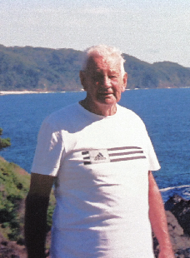

Roland Adams

FINDING THE TIME

Back in the 1950s, the late Roland Adams, who passed away in 2012, noticed an old weathered clock face wedged firmly between rocks below the Lighthouse. When he tried to retrieve it, no matter what he did, it wouldn’t budge. For many years after, whenever he was rock fishing in that vicinity, he would have another go at it, but still to no avail.

Persistence pays off, however, and early in 1990, not long after the December 89 Newcastle earthquake, the old clock face finally came free. Roland was doubly delighted to read on one of Mark Sherriff’s history boards at the Lighthouse that the clock had come from Chance Bros. of Birmingham, England, suppliers of the original Lighthouse equipment.

In fond memory of Roland and his determined efforts, this historical artefact was donated to the museum collection at the Lighthouse by Maureen Adams in 2013.
Jack’s History Page
(All About Fishing – part 2)
THE GROUND FISH RUN

In the 1950s the fishermen on Boat Beach used this term to explain the annual migration of some species of fish that were on spawning runs along the surf beaches.

The ground fish run can begin any time between late March and late April.
It is triggered by autumnal rains that flush the Myall and Wallis lakes and sometimes open the normally closed Smiths Lake.

It usually starts with great schools of bull nosed mullet gathering in the lower reaches and then commencing their spawning run along the surf on the beaches. The mullet surf so close to each other that they form a black mass that is sometimes ten metres in diameter. They are attacked during the run by marine predators, mainly dolphins, sharks, large tailer and kingfish.

Other fish such as bream and luderick also school up in numbers and are to be found under the mullet.

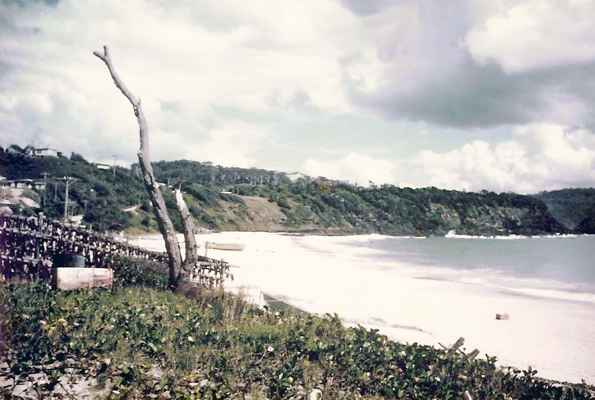
The reefs under the Lighthouse are a natural barrier to the fish and they sometimes hang there for days before going through and around the deep water, and then coming through the gap between Statis Rock and the mainland, and inshore on Boat Beach.

The fishermen and their families in Seal Rocks start to look for this phenomenon from vantage points that give a clear view of the gap.

The mullet appear as a black cloud in the water as they move through and inshore. Bream are seen as a faint yellow/brown shadow because they are on the sand at the bottom. Luderick, also known as blackfish, also school on the surface and are seen as a medium brown colour.

The fishermen wait until the cloud reaches a suitable location off where the Boiler used to be. In earlier days they would then row the
net boat around the school, trapping the fish and then haul them into the beach. It was not unusual to get a truck load of fish in one haul. Nowadays they use fast powered boats to do the netting. The same procedure is used for bream, whiting and luderick in the ground fish season.

Mullet and luderick caught in great numbers were not worth sending to market, so the fishermen spent time filleting them and then salting them in brine, before hanging them out on racks to dry and to be used as lobster bait.

Jack Brown

* * *
Bait racks on the foreshore at Boat Beach

