MANY HANDS MAKE LIGHT WORK

In the final weeks of its 12 month time frame, the federally funded Boat Beach regeneration project came to a stunning climax on Thursday 6th June, when a coachload of dedicated volunteers, mostly from the Tuncurry and One Mile Beach Dune Care groups, descended on Seal Rocks to help the local Weed Warriors plant out a wide swathe of the foreshore strip along Kinka Road.

The weather was perfect, everyone took to the task, and within a couple of hours over 500 seedlings of low to medium height native varieties such as dianella, lomandra, correa, westringia and leptospermum had been planted, watered in and mulched. All the plant stock, supplied by the Great Lakes Council nursery, had been propagated from seed harvested in the area, so as to be genetically pre-conditioned to the harsh coastal climate and given the best chance to survive and thrive.

With the job complete, the energetic team downed tools and moved to the tables in the eastern end reserve, where a well-earned barbeque lunch had been prepared for them.
Co-ordinators Isabelle Strachan and Steve Howard from GLC praised the dedication of the volunteers, for whom age is no barrier.

Among the participants, the Tuncurry Dune Care group, one of the most experienced and productive environmental groups in the region, has a long association with Seal Rocks. For a number of years they have been scheduling work visits to Treachery Beach, where they have had remarkable success regenerating and stabilizing the dunes. This year’s visit will take place on Friday 26th July, starting at 9.00am at Treachery Camp. The coach from Tuncurry will stop at the Seal Rocks Shop on the way through at 8.45am, should any local volunteers wish to join in. It is always a tremendously rewarding day and much is achieved. On the catering side, everyone brings a plate and the morning tea and lunch spreads are legendary.

BOAT BEACH
ECO TOILET PLAN

SRPS has had some encouraging feedback from GLC regarding our long-running quest for the installation of an eco-toilet at the eastern end of Boat Beach. Members attending the last AGM will recall that hopes were rekindled with the advent of the State Government’s Community Building grant scheme, and a resolution was passed that the Committee should approach the Council regarding a funding application under this program. A proposal was drafted and submitted that contained as much detailed information as was available, including preparatory sketches of a concept by SRPS President, Colin Still.

Council has recently replied to the Society, welcoming our efforts and thanking us for being proactive on this matter. This response goes on to say additional site assessment studies are required, including geotechnical, coastal hazard and Aboriginal Cultural Heritage surveys, meaning that a design for a toilet at Boat Beach will not be ready for this year’s grant process. GLC does not presently have the funds for these surveys nor for a final design, however “an application will be made for an allocation of funds for this in the 2014/15 budget”.

SRPS is committed to pursuing this issue to a satisfactory conclusion, in line with one of the objectives in our constitution, which is to ensure ‘the provision of public amenities to enable visitors to appreciate the area’.

AERIAL SPRAY CONDUCTED

This winter NPWS has successfully completed a follow up to last year’s aerial herbicide spray program along the coastal strip adjacent to Seal Rocks. Included this time were the rocky cliffs around the rainforest headland and the island just off the end of Number One. Visual surveys have shown this program to be extremely effective in combatting the infestation of bitou bush in relatively inaccessible locations. The aerial spraying is also being supplemented by ground spraying, the results of which have now become apparent along the verges of Seal Rocks Rd and at other locations in the National Park.

DUMPED FISH
CONTROVERSY

Seal Rocks made headlines in the local and national press last month for all the wrong reasons, after hundreds of undersized bream were discovered to have been dumped just off a walking track in the Myall Lakes National Park at the approach to the village. It appeared to be unwanted bycatch from haul netting of Boat Beach the day before.

A war of words erupted over the days and weeks following, with recreational fishermen claiming that this illegal practice was common, and “an insult to recreational fishers who paid licence fees and were subject to fines for keeping undersized fish.” A spokesman for these stakeholders called for “haul netting of fish like this that are spawning up and down the coast” to be banned, describing it as an “abomination”.

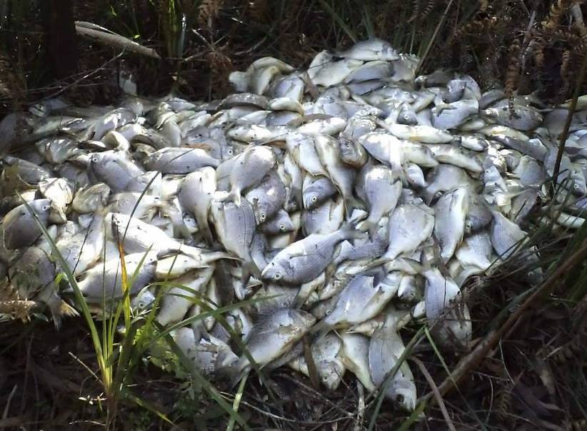

The Department of Primary Industries became involved, saying that it was “disappointing considering that fishers by law are able to use more selective nets that significantly reduce incidental catches of juvenile target species such as bream”. The department said that it hoped to prosecute those responsible for the incident.
The Buzz

WHAT’S IN A NAME?

Quite a bit apparently, when it comes to a film’s potential at the box office. Looks like producers thought “The Grandmothers” might only attract concession card holding seniors, so they quickly changed the title to “Two Mothers” for its Sundance Festival release and “Perfect Mothers” for France.
(Would that have made much difference?) Then, after being picked up for US distribution the title was changed again, to the somewhat more sexy “Adore”. Now the latest is that it will be released in Oz on
22 August, 2013, re-badged as “Adoration”. Why didn’t they just call it “Seal Rocks” - that’s what it’s all about , isn’t it?



RAINFOREST FIELD DAY

Around twenty-five people were present on Saturday 18th May, for a very informative and fascinating venture into our headland littoral rainforest. The morning was divided into two parts, with our first guide being Kim Gollan of Dingo Creek Rainforest Nursery at Bobin, who led us into the forest, identified and spoke about many of the species found growing there, and explained the processes of regeneration and why the Seal Rocks rainforest is such a significant environment.

After refreshments, it was over to Indigenous Heritage Conservation Officer Steve Brereton, who entertainingly outlined the history and involvement of aboriginal inhabitants in this area, past and present, and took the group on a revealing ‘bush tucker’ tour of the rainforest. One particular highlight many will treasure was when the walking track came close to the cliff edge and we looked down into the calm turquoise waters below to see a large sea turtle leisurely swimming in and out of the kelp. A day to remember!

CABLES UNDERGROUND

It’s one of those things that you might not notice at first - but the overhead power lines and telegraph poles beside the road through the rainforest between the Holiday Park and Thomas Road have now been removed. The electricity cables have gone underground beneath the roadside walking path, into ducts laid nearly two years ago. Remember the big, sci-fi looking boring machine? This means that there will no longer be any need for clearing and tree-lopping by the power company along that strip, and this presently degraded section of the rainforest will hopefully now get a chance to grow back to maturity.

* * *

The History Page

NIGHT OF THE THREE WRECKS

Extreme weather around Seal Rocks is nothing new, and conditions experienced in 2013 recall events of 137 years ago, when three vessels, the Hoolet, the Flirt and the Acme, sought shelter in the Bay. The following extract from The Argus, dated July 31, 1876, page 7, Wrecks on the New South Wales Coast, tells of their fate:
A number of vessels came to grief at the Seal Rocks. Three seamen belonging to the ketch Hoolet, owned by Mr. Breckenridge, of Sydney, and which it appeared had been wrecked in Seal Harbour Bay on Sunday, the l6th inst., succeeded in reaching Newcastle on the 21st. The poor fellows had been in great distress, and had walked at different stages from the scene of the wreck. One man, a passenger named Paterson, was drowned while attempting, with the crew, to get ashore. Williams, the master of the Hoolet, states that the ketch, with a crew of three men and two passengers (George Paterson and his wife), left Cape Hawke on the afternoon of the 13th inst. for Sydney, with a cargo of timber and maize. The ketch was driven by stress of weather along shore, and the master ran into Seal Rock Bay for shelter at 9 o'clock the same night and stayed all the next morning. Attempted to put to sea, but the weather was too rough. The gale lasted till Saturday, the 15th, and they could not leave the bay. In the afternoon of that day all hands endeavoured to get ashore in the ship's boat, but about 150 yards from the shore the boat turned over and all in her were thrown into the water. Out of the five in the boat, all managed to get ashore except Paterson, the passenger, who was drowned, and never seen again. His wife was conveyed to the residence of the lighthouse-keeper, and the crew took shelter in a hut on the beach. The next morning at 10 o'clock the ketch, which had her two anchors down, went to pieces. The men remained in the hut till Monday morning, and finding that nothing could be saved from the wreck, they resolved to start for Newcastle.
The crew of the Hoolet also reported the loss of the fore-and-aft schooner Flirt, from Camden Haven, laden with timber, for Sydney, and which entered Seal Rock Bay through stress of weather. She was anchored, and went down just after the crew managed to get ashore. These

men were in the hut which afforded shelter to the crew of the Hoolet, who left them there when they started for Newcastle.
On the 22nd inst. two men belonging to the schooner Acme arrived at Newcastle, and confirmed the loss of that vessel. The following is the report of John Williams, mate of the Acme, as to the cause of the mishap :- "The Schooner Acme, 74 tons, Captain Jackson, laden with 28,000ft of timber, left Camden Haven for Sydney on 11th July. The day following, the wind changed round and blew strongly from south to west, and on the 13th the captain determined to run into Seal Rock Bay. He lay there during the remainder of the day riding the heavy seas with both anchors down. On Friday the wind had increased to a frightful gale and the sea was running mountains high, and fears were entertained for the safety of the schooner. At half-past 7 p.m. the best bower-anchor was carried away, and the schooner commenced to drift a little, but another anchor made fast to a warp was run out, and the men determined to stand by the vessel all night, though much uneasiness was felt lest she would be driven ashore during the night. She, however, stood well to her moorings, and on Saturday morning was in the same position as on the night previous. The wind and sea on Saturday morning increased considerably, and it was considered extremely dangerous to remain on board, so the captain, crew, and passengers left the vessel in a boat and landed safely on the beach. They found shelter in an empty hut which was there, and remained there all Saturday night. At 2 a.m. on Sunday the vessel was still riding at her anchor and kedge and line, and this was the last time she was seen, for by daylight on Sunday morning she had disappeared. The rocks and beach for a long distance were strewn with the vessel's wreck, and it was evident that she had either parted her moorings or had dragged them, and was to pieces on the rocks; nothing whatever was saved. The Acme was a new vessel, having been built only about six months ago, and was owned by Mr. Davis, of Brisbane Water." The men after landing on the beach remained in the hut which had already afforded shelter to the crews of the Hoolet and the Flirt, for some days receiving provisions from the lighthouse-keeper at the Seal Rocks.

Jack’s comment: Must have been some sea ……. and a big hut!

