OSWALD BATTERS SEAL ROCKS

With Easter already behind us, some owners of property in Seal Rocks are still awaiting the resolution of insurance claims, after hurricane force winds, driving incessant torrential rain, created havoc in Seal Rocks over the Australia Day long weekend in late January.

The extreme conditions, part of the Cyclone Oswald low pressure system, were some of the worst the village has experienced in living memory, with the intensity of gusts and deluge hardly abating for 48 hours and reaching a frightening climax about 1 am on the Monday night.

Few houses in Seal Rocks, particularly along Kinka Road, which bore the full brunt, were able to withstand the prolonged battering without some degree of water penetration, and reports were received of flooded garages, guttering and shed roofs ripped off, trees down, and widespread internal damage, as the horizontally

driven rain blew in under doors and around
window flashings and dripped from wet ceilings, one of which reportedly collapsed. The volume of water coursing down Thomas Road caused severe flooding in two houses, which had to be pumped out, and inundation of a third was narrowly avoided by timely sandbagging.

Many holidaymakers cut short their long weekend and headed for home on Sunday morning as the rains began in earnest, but those who hung on got quite a show, with thunderous seas breaking all the way across Sugarloaf Bay and the high water mark practically on Kinka Road. Boat Beach was stripped of sand yet again and the Fishos’ ramp, badly undermined by wave action, broke in two.

The tempest was over by Tuesday afternoon and the clean-up began, but three weeks later, with the towels hardly wrung out, Seal Rocks copped it again. This second storm was just as fierce, but not so long, moving on after 24 hours, and anyway, most of the damage had already been done.
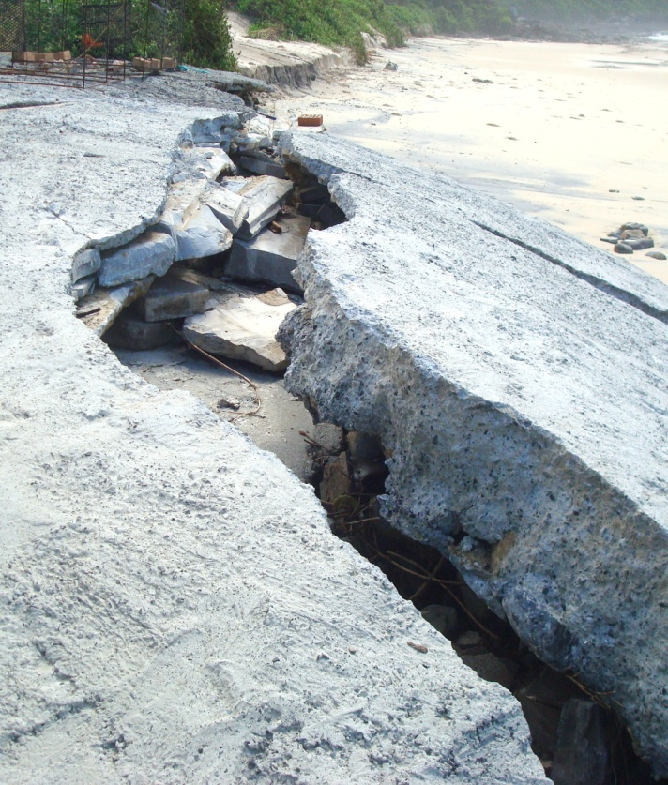

Need some concrete? The Fishos’ ramp after
a visit from Cyclone Oswald

* * *

GUNS SILENT FOR NOW
AT MYALL LAKES

The NSW State Government has announced a few months delay to the start of its trial program to allow recreational hunters to use guns and crossbows in 77 National Parks under its jurisdiction. Myall Lakes NP, which totally surrounds Seal Rocks, is one of those parks listed to be opened up to allow the shooting of feral animals.

According to the Premier, Barry O’Farrell, he agreed to implement this program, proposed by the two Shooters and Fishers Party members who hold the balance of power in the NSW Upper House, in return for their support of his bill to privatise the state’s electricity power generators.

The postponement is due to the fact that police in Orange have laid charges against the former acting chief executive officer of the Game Council of NSW, the body which was to oversee the introduction of the program. The charges relate to 17 offences of illegal hunting and trespass allegedly committed by the former CEO and a fellow volunteer of the Game Council in the Central West area of the state.

There has been a strong reaction to the proposal, with a recent poll indicating 60% of voters are opposed to the idea, and only 38% in favour. The government’s own Risk Assessment draft determined there was a ‘high’ risk of death or injury resulting from the program, with a recommendation that NPWS rangers wear ‘high visibility’ protective clothing as a safety measure.

In response the AWU state secretary has said that: “It’s a ridiculous idea that the safety of workers or national park patrons can be placed in any sort of jeopardy. No AWU field officer will be working anywhere that requires a bullet proof vest.”

Vocal opposition to the program is expected to intensify after 18th April, when former leader of the Greens Party, Bob Brown, headlines a State Parliament House rally hosted by the Public Service Association and the National Parks Association of NSW.

VALE

JOHN CHAPMAN

A much valued member of the Seal Rocks Protection Society, John Chapman, passed away recently in Germany, where he was undergoing medical treatment.
John was a well-known and highly regarded solicitor in the Manly area, loved surfing, and was also a long-time member of Queenscliff Surf Lifesaving Club.

The SRPS expresses sincere condolences to John’s wife Gillian, and to son Lachie.

∞ ∞ ∞ ∞

LEARN MORE ABOUT YOUR RAINFOREST

A very interesting and informative day has been planned for Seal Rocks on Saturday 18th May. A second field day is to be held as part of the regeneration project that is currently being undertaken by SRPS Weed Warrior volunteers. The emphasis this time will be on the rainforest ecosystems that are such a feature of our village environment.

Starting at 10.00am, the first session will be hosted by the very knowledgeable Kim Gollan of Dingo Creek Rainforest Nursery at Bobin, via Wingham. Kim’s focus will be on the intricate processes of ecology and regeneration for a variety of species found locally. After a break for morning tea we will then hear from respected Indigenous Heritage Conservation Officer, Steve Brereton, on the importance of the rainforest to the indigenous people who have lived here throughout the ages.

CLEAN UP WASHOUT

Inclement weather and the resulting low numbers restricted activity in Seal Rocks this year on CU Oz Day. Even so, the few hearty volunteers managed to fill twelve large bags with rubbish collected mainly from Lighthouse and Boat Beaches, and along the Seal Rocks Road. Seems there are still plenty of litterbugs about.

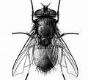The Buzz

SUN SAND SURF AND SEX

Last year’s big local excitement, the movie co-production “The Grandmothers”, now titled “Two Mothers” in the US, and “Perfect Mothers” in Europe, has premiered at the prestigious Sundance Film Festival in Utah to mixed reviews. The film’s controversial storyline, in which two lifelong female friends fall for each other’s teenage sons, apparently crossed a few barriers, exposed a few sensitivities and polarized audiences. Reviewers either loved it or hated it, but there was universal praise for the performances of its two stars Naomi Watts and Robin Wright and for the superb cinematography of Christophe Beaucarne. Without exception, reviews extolled the beauty of the film’s location and the images that had been captured of it. Take a bow Seal Rocks! The movie was snapped up for international distribution and opened in France on 3rd April. An Australian release date is eagerly awaited.

SHIPWRECK DVD

For local history buffs a new DVD has become available, entitled Seal Rocks and the SS Catterthun. It has been painstakingly put together by Max Gleeson, a diver, film-maker and authority on the wrecks along the NSW coast. The ship was lost off the rocks out from the Lighthouse in 1885, and 55 passengers and crew were drowned. The Catterthun was carrying a cache of nine thousand sovereigns when she went down, of which eight thousand were recovered. The DVD can be purchased through Max’s website, and the Seal Rocks shop also has some copies available.

* * *

Jack’s History Page

EARLY SCHOOL HISTORY

The lighthouse keeper William Wallace Williams came with his wife and large family of sons and daughters to the Sugarloaf Point Lighthouse almost two years after it was commissioned in 1875. He was to stay there for the next 20 years.

Several more of his thirteen children were born during his tenure at the Lighthouse, and there were also other families in residence as assistant keepers.

All the youngsters needed education and so Williams applied to have a school built at Sugarloaf Point. This was approved and a classroom was constructed where the garages now are. It was a wooden structure lined with painted canvas – the first school in the area. In 1879 a Mr. F. O. Hely was appointed to teach at Seal Rocks. Teachers in those days were not necessarily trained for the job. Hely was a master mariner, but his English and maths were poor and he resigned after two years. He was replaced by Thomas Powell who was 67 years old and almost completely blind by the time he retired.

Another school was established at Neranie. At that time there were about 100 people living at Neranie and associated in some way with the Hudson sawmill operations on the lakes edge.

William Wallace Williams’ fourth daughter was named Lillian Kate, and she married a Walter Jones, who was appointed teacher at the Neranie School in 1894. Jones remained at the school for 13 years. Another daughter of the lighthouse keeper was Hester Sarah and she also served at the Neranie School, as a sewing mistress.

As the fortunes of the Hudson sawmill declined, the numbers at the Neranie School also waned, and about 1906 the school was finally closed. The residual equipment was transferred from Neranie to the school built for the Croll sawmill families at Bungwahl.

The Croll school building exists to this day and is located past the Community Hall in a sort of cul de sac opposite the old derelict- looking house on the lakeside, as you head towards Bulahdelah.

School fees way back then went something like this:
6 pence for 1child
4 pence each for 2 children
3 pence each for 3 or more children
(A few schools said 6 pence each for the first four and then free after that. At that rate, 4 children meant 13% of a bullock driver’s wage, which was quite unaffordable.)

In the 1930’s the Bungwahl school moved to its present site in the Seal Rocks Road.

Jack Brown
(Many thanks to Betty Bramble for her assistance with some of this information.)

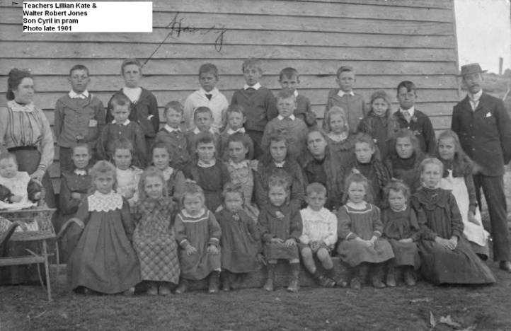
Teachers Lillian and Walter Jones, baby Cyril in pram, and pupils at the Neranie School 1901

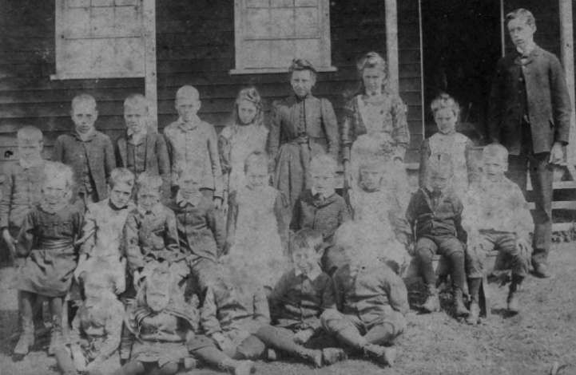
Walter Jones with more of his charges at Neranie

