REGENERATION PROJECT
UP AND RUNNING

As 2012 draws to a close the Society’s Weed Warrior group can look back with satisfaction on a year in which dogged persistence has finally begun to pay off. Not only is the Headland Rainforest starting to look magnificent after years of patient attention, but also the Reserve at the eastern end of Boat Beach is beginning to show a marked improvement.

The twelve month Boat Beach project, which is being funded by the Australian Government’s Caring for our Country, Community Action Grants program, is now in full swing. Past efforts in the precinct are being built upon, and with the deployment of funds, plus an increase in the number of volunteers, rapid progress is being made.

After a well-attended and informative Field Day in September, conducted by professional environmentalist and Bungwahl resident, Tina Digby, working bees were held on alternate Thursday mornings throughout October and November. However, with hotter weather and the approaching holidays, there will now be a recess until February, after which the work will continue on the same fortnightly basis. New volunteers are always welcome.

Local bush regenerator Miles Dixon, who has been involved in earlier environmental programs in Seal Rocks, has been contracted to provide professional guidance and will also conduct the ancillary spraying program. The project’s focus is to reduce the threat of Weeds of National Significance (WoNS) over a two hectare area.

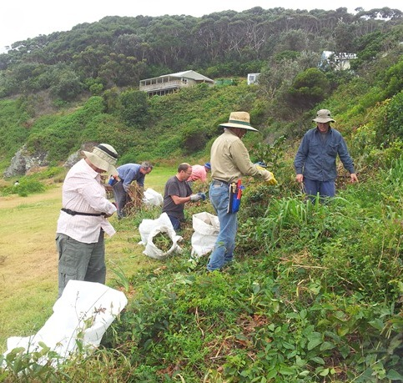

Volunteers have been spreading a large volume of mulch in a wide band around the perimeter of the Reserve, in order to define the grassed area and deter the regrowth of cyclical weeds. Lomandras and other hardy species have then been planted in the mulched areas and more extensive planting with a variety of native species will take place in the autumn. As weeding progresses on the lower slopes, many of the seedlings planted by Weed Warriors during the earlier phase in 2011 are being found doing well, and with an ongoing maintenance program in place, future years should see an abundant return of native vegetation to the area.

* * *

HOLIDAY PARK PLAN
FINALISED

After a very extensive period of development and review the final Plan of Management for the Seal Rocks Holiday Park was adopted by the NSW Minister for Primary Industries, Katrina Hodgkinson, on 25th September 2012. The first draft plan was proposed in early 2010, when the Holiday Park was managed by GLC, but it has reached its ultimate formulation with the park under the control of the Mid North Coast Accommodation Trust. This trust is an arm of the Lands Department, which is now part of the Dept. of Primary Industries.

Along with other interested parties, SRPS has had an ongoing input during this time by way of submissions, and many of our observations and suggestions have been taken into account in the version now adopted. Given general recognition of the need for an upgrade of facilities and infrastructure, the Society’s focus was directed primarily towards such aspects as the visual impact of a re-organised park, enhanced landscaping opportunities, pedestrian safety for park occupants and how they access Number One Beach, diversity in the orientation of cabins adjacent to Seal Rocks Road, and improved integration with the surrounding NP.

A major point of public controversy has been the projected changes to the distribution of permanent van positions within the park, both in respect of numbers and the location of vans. Opposition to these changes has naturally been strongest from those most affected, and if the comments reported in the Advocate following the adoption of the final plan are accurate, it seems likely a challenge to the plan will be lodged with the Land and Environment Court.

For anyone wishing to view the final plan, it is currently available online as a .pdf document, via www.crownland.nsw.gov.au . Select the sub-heading ‘About Crown Land’, and then from the drop down menu to the left select ‘Adopted Plans of Management’. The Seal Rocks Holiday Park plan is first on the list, being the most recent, and it concludes with an Appendix containing, among other things, a diagram of the revised layout for the park.

* * *

VALE

RON TAYLOR (1934 – 2012)

ROLAND ADAMS (1935 – 2012)

Sadly, in the past few months the Seal Rocks Protection Society has seen the passing of two of its long term members and ardent supporters.
Ron Taylor and Roland Adams both had a deep attachment to Seal Rocks, and a lifelong commitment to the preservation of those unique qualities that always drew them back to the village they loved.
To Valerie Taylor, Maureen Adams and their respective families, we extend sincere condolences.
∞ ∞ ∞ ∞

The Buzz

COMPETITION FOR THE WHALES

The sparkling waters of Sugarloaf Bay were graced by more than Humpbacks and Southern Rights this spring, when a couple of other infrequent visitors dropped by. It is some time since we saw Young Endeavour, the 239 tonne, brigantine rigged, tall ship that was Britain’s 1988 bicentennial gift to Australia. In September she moored in the bay overnight and her beautiful lines enhanced the view before she hoisted sail and continued on her way.

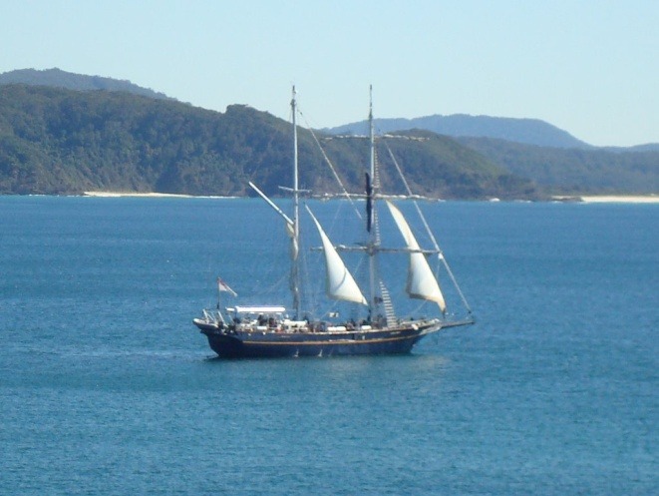

October brought an even rarer visitor, when an Australian fur seal was sighted frolicking in the calm waters of Boat Beach, metres from the shoreline. Most locals could not recall ever having seen one on Boat Beach, and getting a good pic proved difficult, as the agile mammal was a bit camera shy.

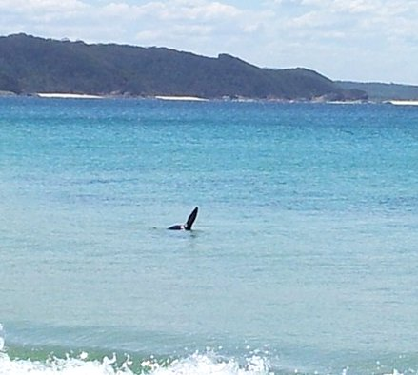

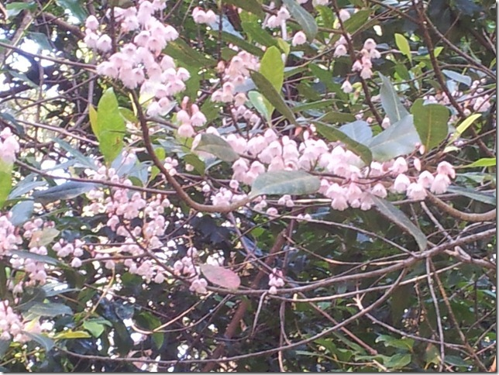
Something to look out for if you venture into areas of Seal Rocks rainforest during
November/early December is the spectacular display of the Blueberry Ash, which can sometimes keep its deep blue fruit right through the next flowering.

MOVIE RELEASE

Been wondering what’s happened to that movie we all got so involved in the making of earlier this year? Apparently the title has been changed from ‘The Grandmothers’ to ‘Two Mothers’ and the latest from Peter Lawless, the location manager who kept the community in touch, is that the release date will be shortly after the next Cannes Film Festival in France, which takes place in the second half of May 2013.


Jack’s History Page

WHEN THE RAILWAY
CAME TO BUNGWAHL

In the early 1970's our son Peter was an engineering student. At the lectures he met a fellow student named George Hudson. They became mates and in time George was invited to spend the weekend with us at Treachery. He became a regular visitor to our accommodation there.

One year George brought his mother to stay for a few days, and whilst talking to her I discovered that she was part of the Hudson family that originally started the big saw mill operation at Neranie. She told me that around 1900 the company had timber leases over almost all of the shores of Smiths Lake and also up Tarbuck Creek.

The difficulty in drawing logs from these areas was that in the sand country the bullock wagons would become impossibly bogged. On the other shores of the lake steep rocky hills dropped down to the lake edge, again making bullock operations difficult, if not impossible. It was therefore decided that the company should purchase a couple of steam engines and provide loading facilities at the lake and a railway at the saw mill at Neranie.

The facilities provided were a low ramp running out into Smiths Lake on a sand bank near Dogwood Road and the railway line running from this ramp to the Neranie mill. A further loading ramp and railway line was constructed up the side of Tarbuck Creek.

All this happened over one hundred years ago, but the remnants of this operation can be seen today. The remains of the ramp that ran out on the sand bank can still be seen when Smiths Lake is open to the sea and the lake is at a low level. All that remains are some piles and a few cross beams.

Further evidence is on the lake side of Dogwood Road, where the road climbs a small hill rise. Cut into this rise is a trench that provided a gradual incline for the railway tracks. The line appears to have travelled in the direction indicated by this cutting, to cross Dogwood Road and then run down the Bungwahl side of the house opposite the Fishermans Co-op.

This house was owned by the Gray family, and Betty Bramble tells me that Cyril Gray showed her a section of the steel railway line located in the paddock beside the house. I have looked in vain for further evidence of the remains of the rail track between the Co-op and the saw mill at Neranie.

The railway line only lasted a few years and then the whole operation closed down. The engine was sold to be used on the breakwater in Forster.

Jack Brown

McBride’s Horse Team

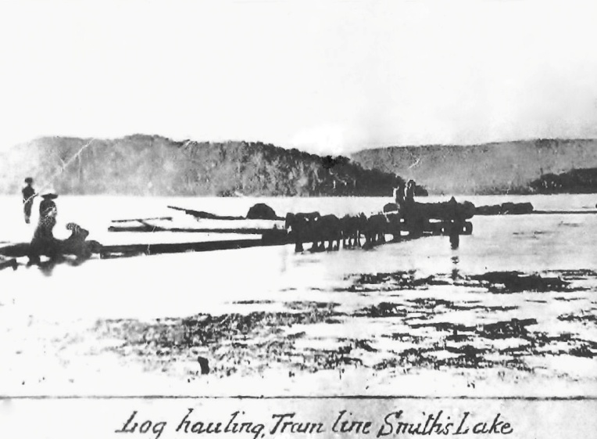

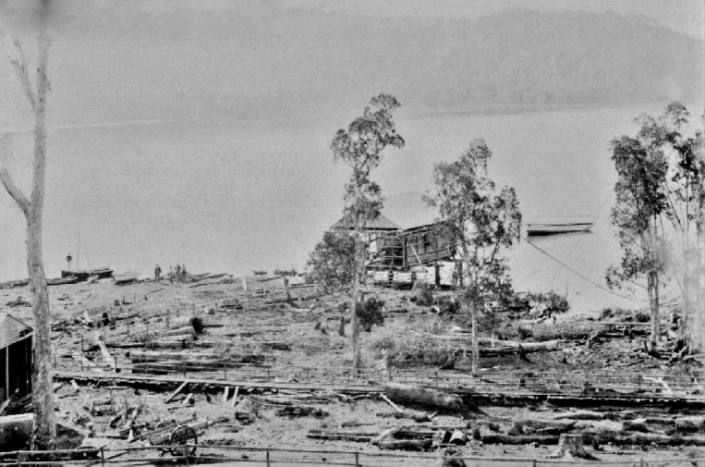

The Mill at Neranie pics courtesy of B. Bramble

