FUNDING FOR THE SEAL ROCKS ENVIRONMENT

In a ‘late news’ insert in the July issue of this newsletter it was announced that GLC and NPWS had secured a $785,000 grant over 5 years to address the threat of specific weeds in the Cape Hawke and Seal Rocks areas. This funding has been obtained through the Australian Government’s Clean Energy Future Biodiversity Fund.

The program that will be implemented as a result of this grant is still in the planning stages, but is expected to have a wide-ranging impact on bitou and other noxious weeds that are supplanting native vegetation along this part of the east coast. Both GLC Bushcare Officer Isabelle Strachan and NPWS Ranger Rachel Kempers agree that the positive outcome of this program is likely to be “huge”.

There is further good news. A separate, smaller grant of $18,000, to continue and expand the award winning regeneration project that has involved the Society’s Weed Warrior group at the eastern end of Boat Beach, has also been approved, and will run for the next twelve months. The bulk of

these funds will be used to employ a team of professional regenerators, whose expertise should greatly enhance the efforts of the Weed Warrior volunteers, who will continue to be involved on a regular basis.

It is gratifying that the persistence of this small band of volunteers is beginning to pay dividends. In demonstrating our community group’s ongoing commitment to the environment by being involved in the Boat Beach project and also the Headland Rainforest regeneration project, we have both encouraged the statutory bodies to give greater attention to the weed problem in the Seal Rocks area, and have been an essential participant in the successful funding application.

After acquiescing late last year to a request to suspend activities for several months, leading up to and during the filming of
“The Grandmothers”, and then being forced to further delay resumption of the project because of continuing inclement weather, winter ills etc., it has been disheartening to see the amount of weed regrowth that has occurred around the Boat Beach Reserve during this period. However, despite the setback, news of the grants has lifted spirits again and Weed Warriors are committed to continuing the fight on all fronts.

There will be 12 formal weeding days between now and the end of June 2013, to satisfy the conditions of the smaller grant, and two field days. These field days will be public education events, and will be led by professionally qualified environmentalists.
The first of these will be held on Saturday 29th Sept. 2012, during the school holidays,
(see box notice below for details).

It is important that this field day should be well attended, not only because of the detailed information it will provide on the program, but also to demonstrate our community’s support for this major expansion of the weed control efforts in and around Seal Rocks.

SEAL ROCKS
FIELD DAY

A PUBLIC EVENT TO FOCUS ATTENTION ON THE UNIQUE SEAL ROCKS ENVIRONMENT AND THE STRATEGIES BEING EMPLOYED TO REDUCE THE THREAT OF INVASIVE WEEDS

WILL BE HELD ON

SATURDAY
29TH SEPTEMBER 2012

IN THE CLEARING AT
THE START OF THE
HEADLAND RAINFOREST TRACK
(100m WEST OF THE SHOP)

COMMENCING AT
10.30 AM

ALL WELCOME

VILLAGE FIRE TRAIL

In a review and update of the bushfire hazard reduction strategies for combatting any fire that might threaten the village, NPWS in conjunction with other bodies, undertook for the first time, back in October 2010, an 800 hectare fuel reduction burn to the south and west of Seal Rocks.

Although it was also considered desirable at the time, an upgrade and extension to the existing fire trail behind the houses along Kinka Road was deferred, mainly because of the difficulties posed by the topography. There are also problematic questions regarding soil and vegetation conservation issues that such an upgrade would entail, as the bush sand surface would have to be reinforced to permit access to large fire-fighting vehicles.

Now in 2012, this proposal to rethink the fire trail has been given a higher priority, and initial exploratory discussions and on-site investigations have taken place between NPWS, PICLD (Lands Dept.) and soil conservation professionals. It is still early days and there are many issues to be addressed before any final alignment can be determined. There does, however, seem to be a will to proceed to establish a fire trail to provide more comprehensive protection to all the properties along Kinka Road.

* * *

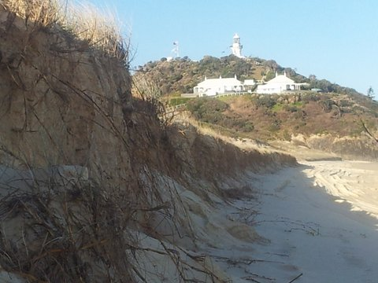
Heavy seas in early August left two metre sand cliffs along much of Lighthouse Beach
The Buzz



BIRTHDAY GIRL

On Saturday 28th July, a host of friends and relatives gathered at Betty Bramble’s home on The Lakes Way, Bungwahl, to participate in her lively 80th birthday celebration. Betty has been a member of SRPS since its inception, and her ongoing commitment to the local community has set a high benchmark. Betty’s knowledge of the whole of the Myall Lakes area is legendary, and her public speeches are always a treat. To hear her speak in detail of the bygone days of those who lived and worked around the lakes is indeed an education.

In particular, her memories of the contribution made by the Bramble family and other notable personalities during the early days paint a vivid picture of a pioneering society where fellowship was primary. Another foundation member of the Society, Jan Bennett, read a poem that she had composed in tribute, and all present joined in a heartfelt rendition of Happy Birthday to an ever-youthful Betty Bramble.

UPDATING of
CONTACT DETAILS

A humble request from the
Hon. Secretary

If the postal address for your newsletter needs to be corrected in any detail, could you please update by sending us a note, either by snail mail or to:
protectionsociety@hotmail.com

Also, since the newsletter is published quarterly, it means that matters arising at short notice between publication dates
can most effectively be conveyed to members and friends via email : -
events at the Lighthouse, closing dates for submissions, changes to community working bees, et cetera.

For those who, up until now, have not been contactable by SRPS via email, but who wish to be kept informed of matters pertaining to the Society, could you please let us know what your current email address is. It would make things a lot easier for everyone.

Many Thanks

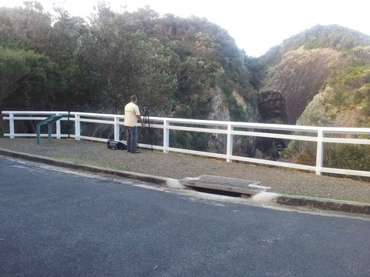
New fence at the lighthouse Blowhole. Did we really need it? Stands out like ………..!

Jack’s History Page

THE MYSTERY
OF THE DISAPPEARING
WATER SUPPLY

In Rosemary Broomham’s very readable book Myall Lakes National Park: a people’s history, published by the NPWS in 2010, mention is recorded of the “Primitive Park”, as it was known, established behind Lighthouse Beach in the days before it became part of the extension to the NP. This reminded me of the problem I once had with a disappearing water supply at Treachery.

Back in the 1980’s the water supply for the whole of Treachery came from a spear pump in the camping ground. It was a crude device and pumped slowly up to a tank behind the farmhouse, and from there distributed to all the taps around the camp.

The managers at the time reported to me that we must have a leak in the PVC water pipes because they were finding that they had to pump almost continuously to maintain water supply. I spent several weekends looking for the leak but couldn’t find one.

The next time I came up I was greeted by regular Peter Fenning (Feno), a Bulahdelah local who had a van in front of where the log cabins now are. He conveyed the news that he had gone for a walk onto the headland and had found hundreds of marijuana plants out there. They were in all sorts of pots of various sizes, up to galvanised buckets, and were hidden in the bush. He had also found an elaborate watering system tapped into our water pipes.

At this time there were a lot of “hippy” type young people camped permanently in the bush behind Lighthouse Beach. They were known to the locals as “bush ticks” (because they got under our skin and were very irritating!)

Notable amongst them was a known drug dealer who already had several convictions and was under surveillance from both customs and the police.

I became angry and rang the sergeant at Bulahdelah Police whom I knew.
He got the details and told me to avoid the headland. The next weekend I came up again and was told that nothing had happened but that the Police seagoing boat had been seen steaming off Lighthouse on several days.

The next morning Feno took his boat around to Boat Beach just on dawn and was preparing to launch it when he noticed a luxury motor cruiser nosing into the bay.
He launched his boat and gunned the motor heading out to sea. On seeing Peter’s boat approaching, the motor cruiser gunned its engines and retreated out towards the horizon. At the same time every bush on the beachfront revealed a customs or a police officer who had been waiting in hiding. Feno had inadvertently wrecked a trap for a major drug runner!

Later that day I was confronted by a 4WD with four burly surfies, complete with surfboards, heading out on to the headland. I told them that I couldn’t allow them to go out there until the police arrived. With a grin they told me they were the police. They subsequently arrested the drug dealer on Lighthouse Beach and I had no further trouble with the water supply.

I don’t know if they put him away on that occasion, but later on I heard that the same bloke had been arrested trying to leave the country with a suitcase full of marijuana, heading for New Zealand.

Jack Brown

* * *

