14th July marks 20 years since the famous 1992 stranding of 49 pilot or false killer whales on Lighthouse Beach, a fateful event that led to an extraordinary rescue effort and turned the spotlight of the world’s media onto the sleepy little village of Seal Rocks. The dedication of hundreds of volunteers and trained professionals to the arduous and emotional task of saving the distressed mammals was joyfully rewarded when 37 survived and took to the sea again from the calmer waters of Boat Beach, to where they had been moved. The Great Seal Rocks Whale Rescue proved to be the most successful ever undertaken and the lessons that were learnt here have been applied advantageously ever since.

Jack Brown recalls the events as they unfolded: “ It started for us early in the morning when a phone call came from Brett Martin of the Bulahdelah police and Wayne Kelly who was the lighthouse keeper then. We were living in the big log cabin at Treachery at the time. They wanted to know if there were any whales beaching themselves on Treachery Beach. I took my binoculars and went out onto the headland but there were no whales on Treachery Beach. On returning to the cabin, a look with binoculars down to the Lighthouse showed whales stranded on the beach there and others still in the water coming ashore.

The next phone call was from the National Parks ranger wanting to know about vehicle access to Lighthouse Beach, which was only the twisting four-wheel-drive track at Treachery end. I arranged to meet her and take her to the site in my Land Cruiser. When we arrived we saw that some locals were already there trying to turn those whales still in the water around and push them back out to sea. Already on site were members of the ORRCA whale research group. Notable amongst this group was Anne Ditton. When we arrived she was instructing willing volunteers to stop trying to push the whales back out to sea, but rather to let them come ashore and immediately check that their breathing hole was in an upright position with no sand lodged in it. 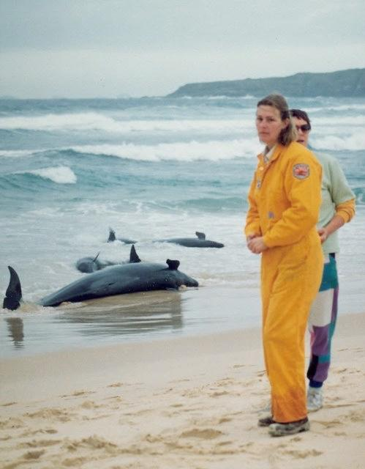
The face of concern - Anne Ditton from ORRCA

Next she called for buckets and basins for
volunteers to splash seawater over the whales to keep their skins wet. By this time things were really starting to happen - lots of people were coming down from the Lighthouse and, with the news out, I counted six helicopters parked on the frontal dune. Well-resourced organisations of National Parks, Police and Great Lakes Council were now moving in.

Because the sea was fairly rough it was decided that the whales would have to be moved to a more sheltered site at Boat Beach. In a short time a navy Sea King helicopter arrived for the purpose of trying to airlift the whales in a cargo net from Lighthouse Beach to Boat Beach. To try this idea out a large dead whale was loaded onto the cargo net and was lifted into the air by the helicopter. The trial being satisfactory they then loaded a live whale into the net, but on lift-off the whale went berserk and had to be lowered back to the ground. It was then decided that the whales would have to be individually loaded onto a trailer and towed there. This meant that a track along the beach had to be smoothed out and the twisted track off the beach at Treachery end had to be remade as a straight driveable track to the roadway.
The day was spent in transporting the whales to Boat Beach and I spent my time providing equipment and some food and drink for those doing all the work. It was a very long day and I still had the now overloaded camping ground to run. The part played by the ORRCA organisation and in particular Anne Ditton was vital to this rescue. Organizing the stabilization and calming of the whales on the beach was the equivalent of CPR in human terms.”

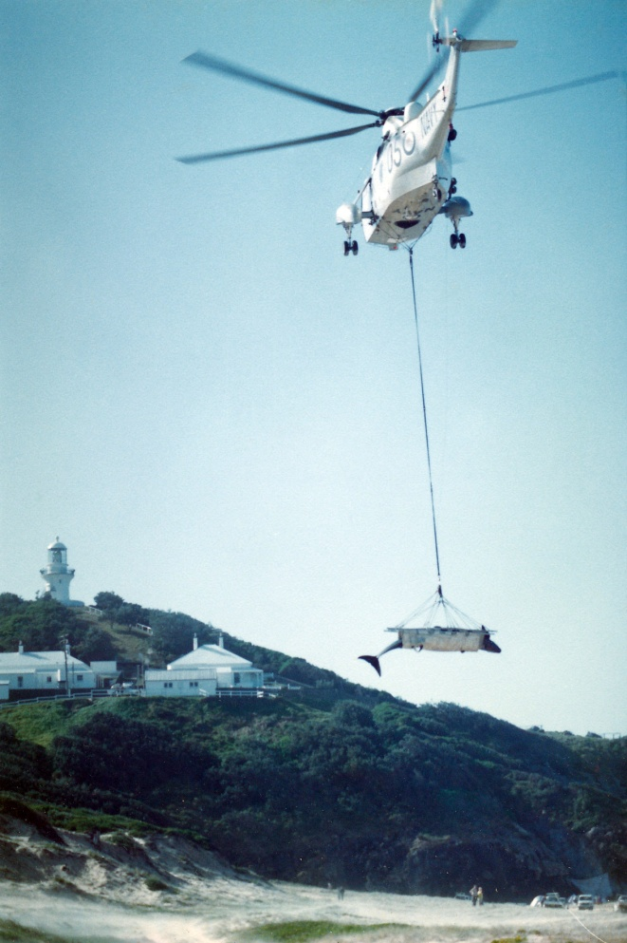
Trial airlift of dead whale

Jan Bennett noted down her impressions of the day: “At 1.30 pm I joined the bucket brigade. Although nobody seemed to know what to do, we soon learned. The advice we were given and passed on to others was: Don’t pour water on the blowhole or the whale could drown if it ingests the water - pour water over the fins and tail as these are the areas that heat up most. Make sure that the side fins are able to move. If the whale’s temperature rises, air and water around the fins will help to cool it down. Be careful when rolling a whale that the side fins are
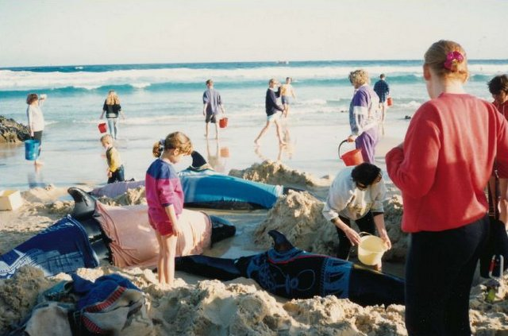
folded into the body. A broken fin will probably be fatal for the whale. If the waves roll in, lift the whale’s head so that the water won’t cover the blowhole.”

Jan wrote that everyone had the one thought in common - to make each whale as comfortable as possible and keep it well enough to make the long trip by trailer to Boat Beach. Jan recalled the enormous weight of a whale she helped lift onto the trailer and the touch of another as it moved its side fin across her hand when she cleared some sand
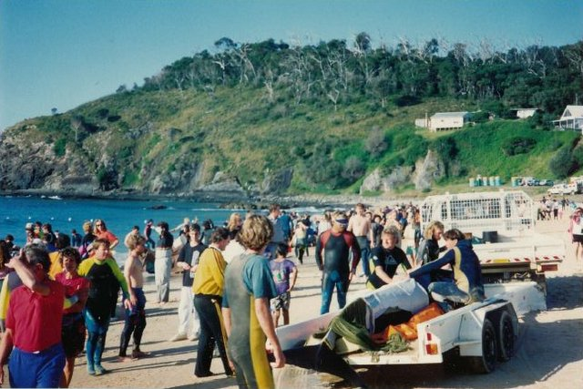
from around it. An indelible memory was of the baby whale that thrashed its tail wildly just before it died.

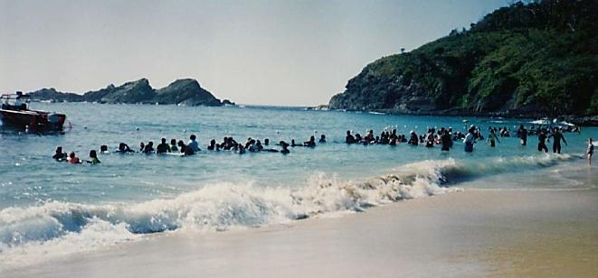
At Boat Beach, where the surviving whales were nursed both on the sand and in holding pens, the tireless effort continued for the next two days. A plan was devised to tow three of the larger ones out to sea in a floating cage, with the hope that their signals would entice others to follow. No one knew for sure whether this plan would work but it was thought to be the best chance.

Preparing to put the release plan into action

The Bucket Brigade

A patient arrives at Boat Beach

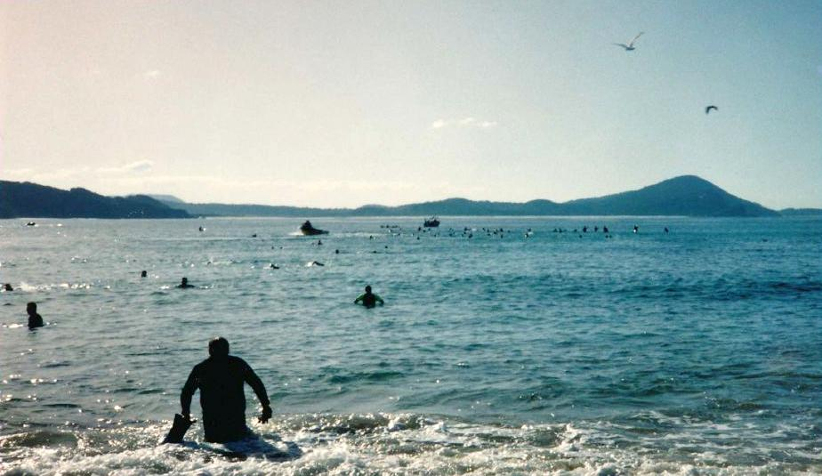
In the event, despite some initial hiccups, the gamble paid off and 15 of the healthier whales headed out of the bay, later joining another pod swimming north. As the weaker ones left behind regained their strength they too were released in groups and it gradually became clear that a remarkable success had been achieved. Many of the rescuers, united in their goal, had pushed themselves to the limit to save these whales, and their resourcefulness and determination had won through. There has been no prouder moment in the history of Seal Rocks.

Jack’s Postscript:

I first became aware of pilot whales in the seas off Seal Rocks in the 1950s when I used to go to sea with professional fisherman George Campbell in his boat Seafoam. I assisted him with fishing and hauling traps. We often saw considerable pods of these whales milling around in the ocean. They can number 50 or 60 in a single group. The first stranding that I saw was also in the 1950s when a small pod beached themselves on Lighthouse Beach in front of the big sand scar. George was paid by researchers from Sydney to sever the heads of two of them, pack them in ice and dispatch them to Sydney for research purposes.
Our thanks go to Jack Brown and Jan Bennett for contributing not only their recollections, but also the photographs for this first colour edition of the Seal Rocks News. Future editions will continue to be presented in colour, but will return to the more usual format.
Editors

Success! Heading for open water again

The next big stranding occurred on Treachery Beach on 1st June 1980 when a large pod beached themselves on the sand hard against Treachery Headland. Council and National Parks were unable to save many of them and rather than watch them die a slow death those still alive were shot. Council took earthmoving machines down onto the beach and dug a deep trench hard against the headland and buried them all in the frontal dune. Then 12 years later came the big whale rescue described above.

The annual migration of whales is now occurring past Seal Rocks. Because there is a four knot current running south the whales come along Treachery Beach just outside the wave breakers. An excellent point to see as many as 20 groups in a day is out on Treachery Headland or from the parking area in the middle of Treachery Beach.

